**Expression of Interest (EOI) for Consulting Services for Developing a Web based Paurashava Road, Drain and other urban infrastructure Inventory Management Software in LGED**

**Invitation Ref. No. – JMIIP/EOI-21/1**

November 22, 2021

|  |  |
| --- | --- |
| **Submitted To:** | **Ministry of Local Government, Rural Development & Cooperative**  Local Government Engineering Department LGED Annex BLDG, 62 West Agargaon,  Sher-e-Bangla Nagar, Dhaka-1207. Bangladesh. Tel : 880-2-58157510 e-mail: pd.jmiip@lged.gov.bd |
| **Submitted By:** | **Sheba Technologies Limited** 8th Floor, Khawaja Tower, 95, Mohakhali C/A, Dhaka-1212 |



*Date: November 22, 2021*

**Nayeema Nazneen Naz**

Project Director  
Jamalpur Municipality Infrastructure Improvement Project (JMIIP)  
Local Government Engineering Department  
LGED Annex BLDG, 62 West Agargaon, Sher-e-Bangla Nagar,  
Dhaka-1207. Bangladesh.  
Tel: 880-2-58157510; E-mail: pd.jmiip@lged.gov.bd

**Subject: Expression of Interest (EOI) for Consulting Services for Developing a Web based Paurashava Road, Drain and other urban infrastructure Inventory Management Software in LGED.**

EOI Ref. No. – JMIIP/EOI-21/1

Dear Ma’am,

With reference to your invitation on the subject mentioned project we are pleased to submit herewith our Expression of Interest for your kind consideration.

We are Submitting the Expression of Interest in following description:

**Sheba Technologies Ltd.**

8th Floor, Khawaja Tower, 95, Mohakhali C/A, Dhaka-1212

**Sheba Technologies Ltd. (STL)** is a subsidiary of Sheba Group which has over 20+ years of management experience with proven track record in rendering technologically advanced products and services. STL assists you to develop tailor-made software from scratch. A team of system analysts work on the solution architecture in a way that is designed to solve our client’s business/technological problems. STL brings business and application developer skillsets together to formulate necessary technical requirements and develop the best possible solution. Since its inception, STL has had the privilege to work with top Private, Non-Government and Public organizations where it ensures delivery of world class services and enterprise solutions. Within this short span of period, it also successfully produced and launched a robust in-house developed product.

We are always keen on listening to our customers and are constantly learning from their experiences while rendering Telecom and IT services. This has made us recognize the importance of evolving into the new ‘normal’ which is ‘Data is everything’. With this aspiration, STL is fully committed to bring world class technologically advanced Business Process Automation by delivering architecturally superior Software solution, Off-the-Shelf customizable Software, Digital Identity platform for Citizens, Smart City initiatives, Artificial Intelligence and Machine Learning to our esteemed clients who are also our long-term strategic partners.

The EOI has been prepared on the basis of information provided in the invitation.

Now, to substantiate our standing, we enclose herewith the EoI document which is reflective of the adequacy of our professionalism, capabilities. We believe that with the delineated skill and expertise, you will find our EoI document adequate to shortlist us for the stated assignment.

We assure you that we will be available to respond any of your queries that you require to get clarification on.

We would expect to hear from you soon.

Thanking you,

Yours Sincerely,



**Farhan Islam**Head of Business Operations  
Sheba Technologies Limited  
Phone: +8801711547804  
Email: [farhan.islam@shebatech.com.bd](mailto:farhan.islam@shebatech.com.bd)

**Table of Contents**

[**1** **Background and General Information of the Firm** 5](#_Toc87954617)

[1.1 OVERVIEW OF SHEBA TECHNOLOGIES LIMITED 5](#_Toc87954618)

[1.2 History 5](#_Toc87954619)

[1.3 Legal Documents 6](#_Toc87954620)

[1.4 Brochure of STL 20](#_Toc87954621)

[**2** **Experiences of the Firm in Key Operating Areas** 40](#_Toc87954622)

[**3** **Financial Capacity of the Firm** 42](#_Toc87954623)

[**4** **Organizational Capability of the Firm** 70](#_Toc87954624)

[**5** **Logistics Resources of the Firm** 79](#_Toc87954625)

[**6** **Availability of Technical Experts for Performing the Assignment** 81](#_Toc87954626)

# **Background and General Information of the Firm**

## OVERVIEW OF SHEBA TECHNOLOGIES LIMITED

Sheba Technologies Limited (“STL”) was formed primarily to participate in the various exciting opportunities associated with the efforts of the Government to transform the country into Digital Bangladesh.

STL is a sister concern of Sheba Group and the “Sheba” name is one of the premium brand in the country’s telecommunication arena with over 20+ years of state of the art technological and management experience with proven-track record.

STL’s core areas of expertise and focus are to provide solutions to various enterprise customers by supplying infrastructure for Mobile Broadband, Data Centers, Cloud Service, Call Centers, Location Based Service, Value Added Services (“VAS”), Cyber Security and Smart Grid Solutions.

## History

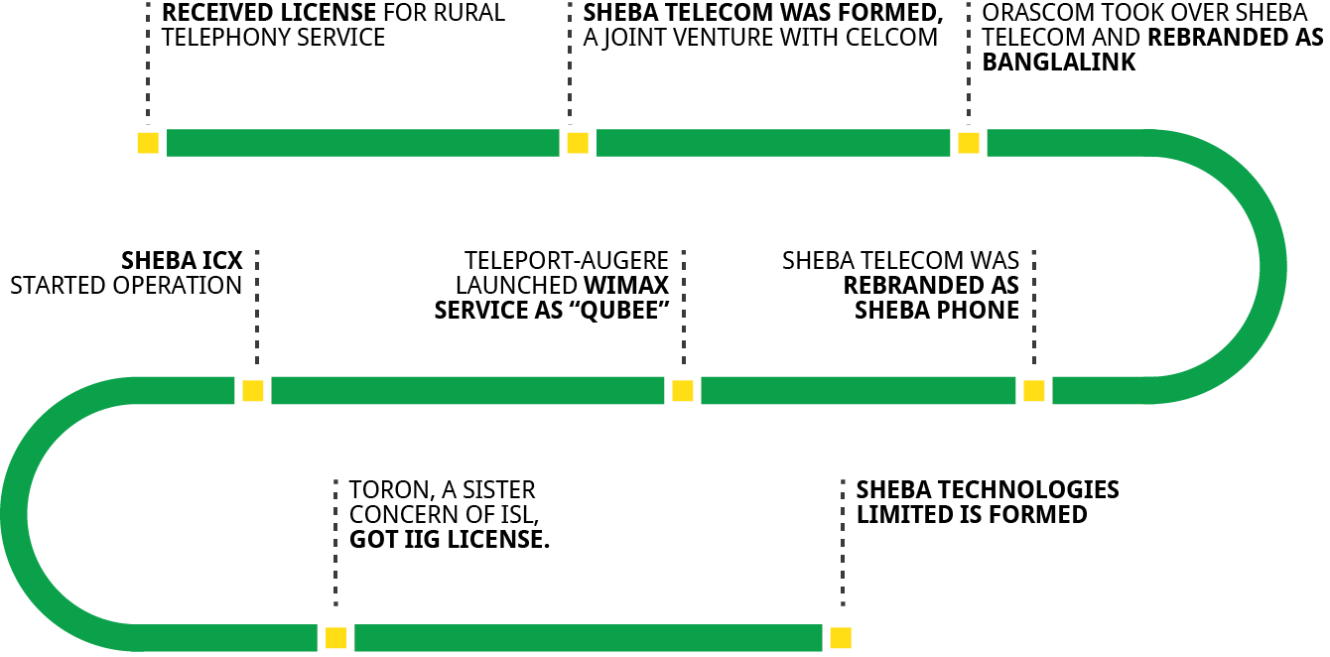

## Legal Documents

|  |  |  |
| --- | --- | --- |
| **Name of the Company** | Sheba Technologies Limited | |
| **Contact Person:** | Farhan Islam Head of Business Operations Phone: 01711547804 Email: farhan.islam@shebatech.com.bd | |
| **Constitution & Year of Establishment:**  Incorporation Year: 2015 |  | |
| **Registered Office/Corporate office/Mailing Address:** | Registered Office: H # 55, R # 4/A, Dhanmondi, Dhaka-1209, Bangladesh  Corporate Office: 8th floor, 95, Khaja Tower, Bir Uttam AK Khandakar Road, Mohakhali CA, Dhaka 1212 | |
| **Trade License(01)** | F:\Trade License STL_2020-1.jpg | |
| **Trade License(02)** | F:\Trade License STL_2020-2.jpg | |
| **TIN Certificate** | F:\TIN Certificate of STL-1.jpg | |
| **Income Tax certificate** | F:\Income Tax Certificate of STL for FY 2018-2019-1.jpg | |
| **VAT registration certificate** | F:\VAT Certificate of STL-1.jpg | |
| **BASIS Membership Certificate** | **Note:** We are yet to receive our BASIS 2020 certification hardcopy due to the current close down. | |
| **CMMI Level 3 Certification** |  | |
| **ISO 27001:2013 Certification** | E:\Tahsin STL\Legal Documents\STL Legal Documents\ISO 27001-2013.jpg | |
| **ISO 9001:2015 Certification** | E:\Tahsin STL\Legal Documents\STL Legal Documents\ISO 9001-2015.jpg | |
| **Tax Clearance Certificate for last 3 years** |  | |
|  |  | |
|  |  | |
| **Bank Solvency Certificate** | C:\Users\User\Downloads\Bank Solvency certificate_latest-page-001.jpg |
| **Tax Exemption Certificate** |  |

## Brochure of STL

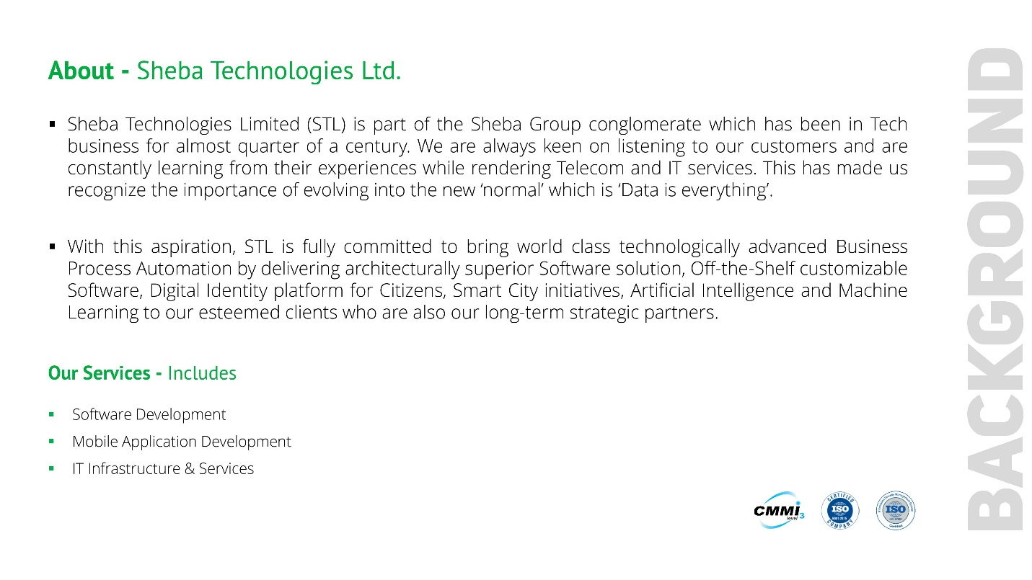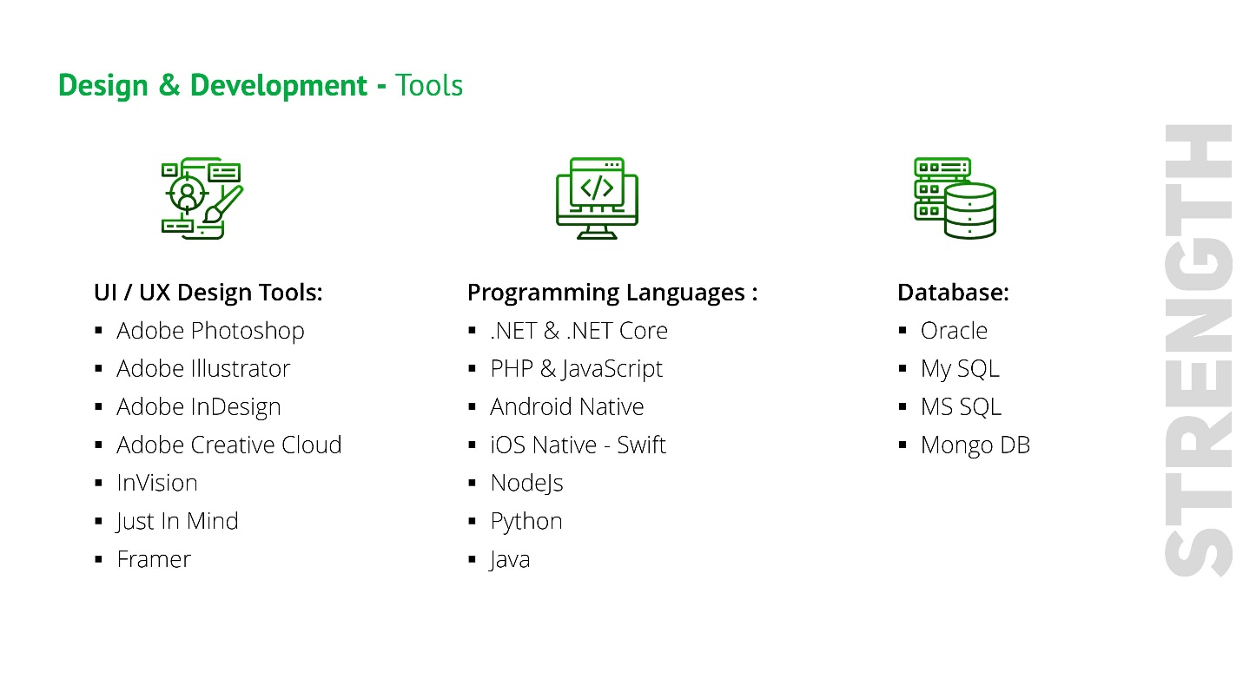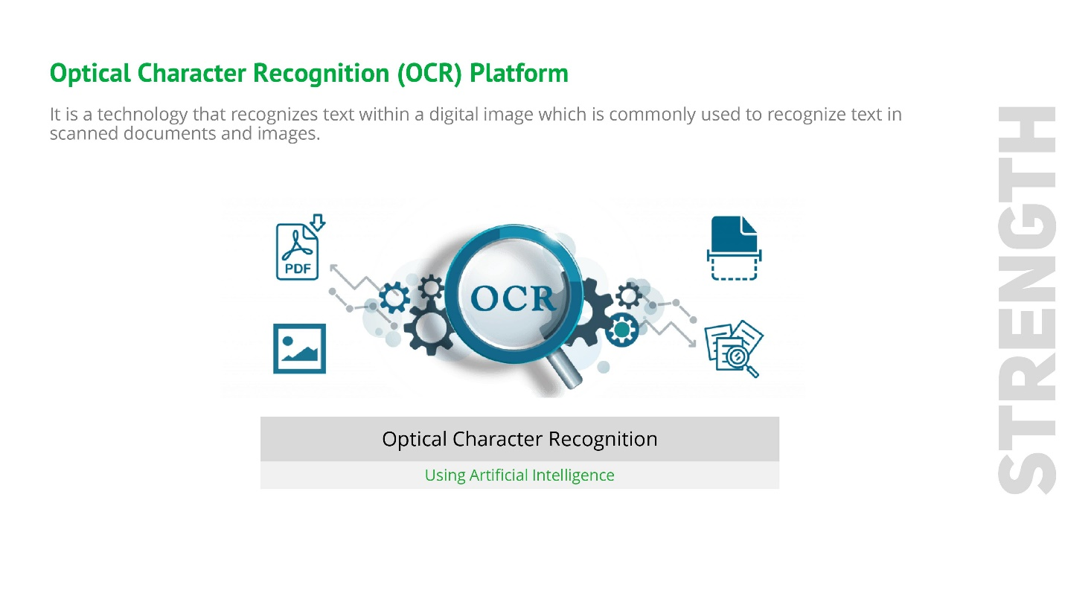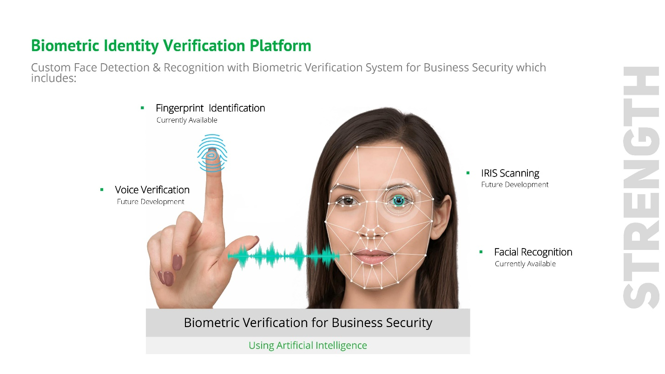

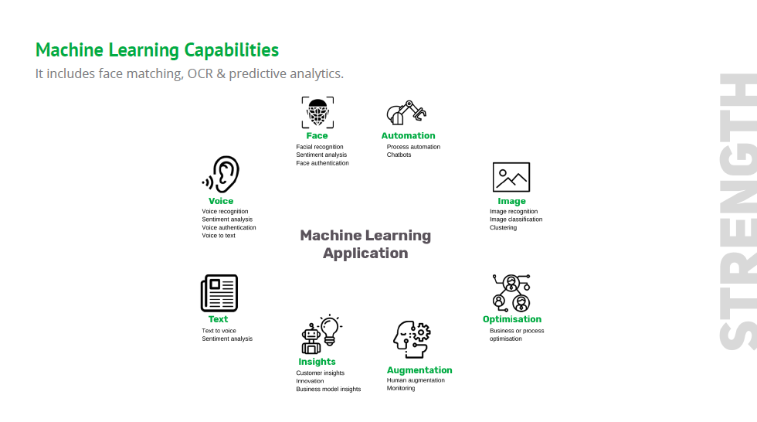

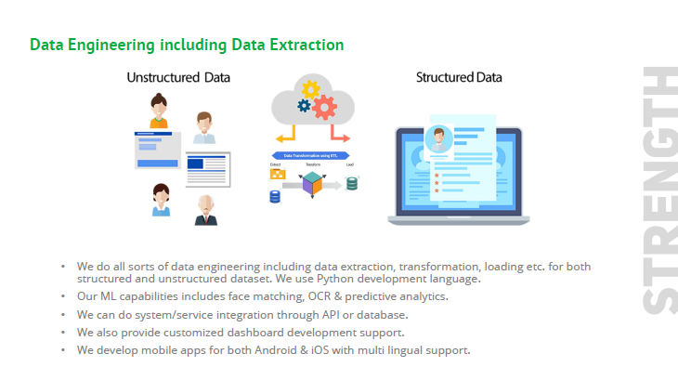

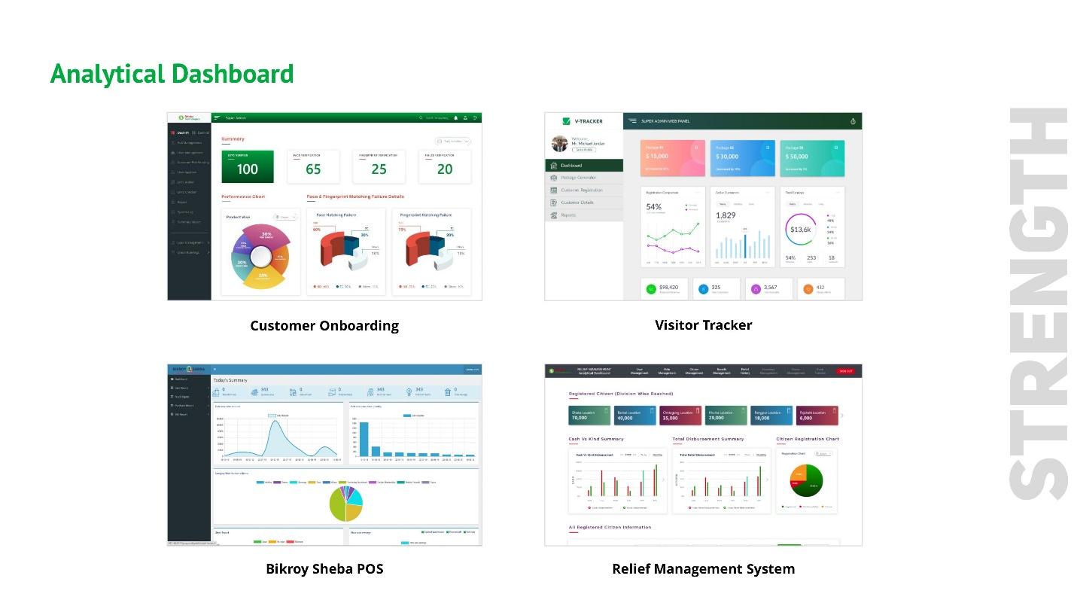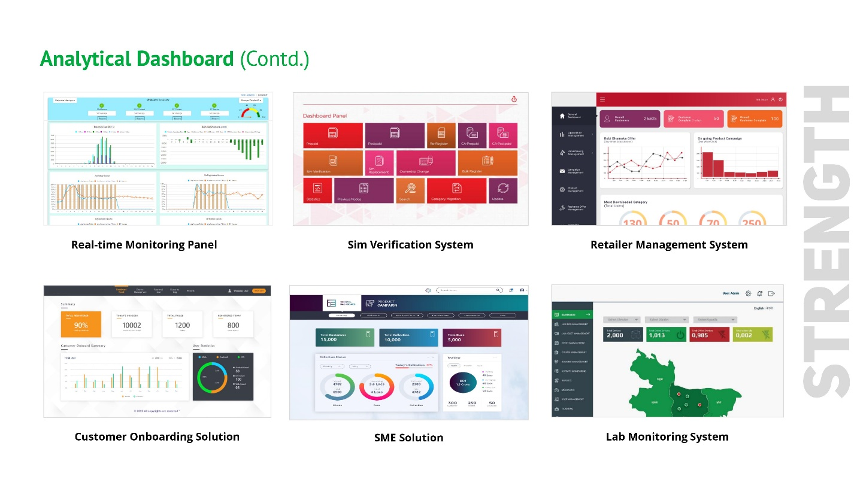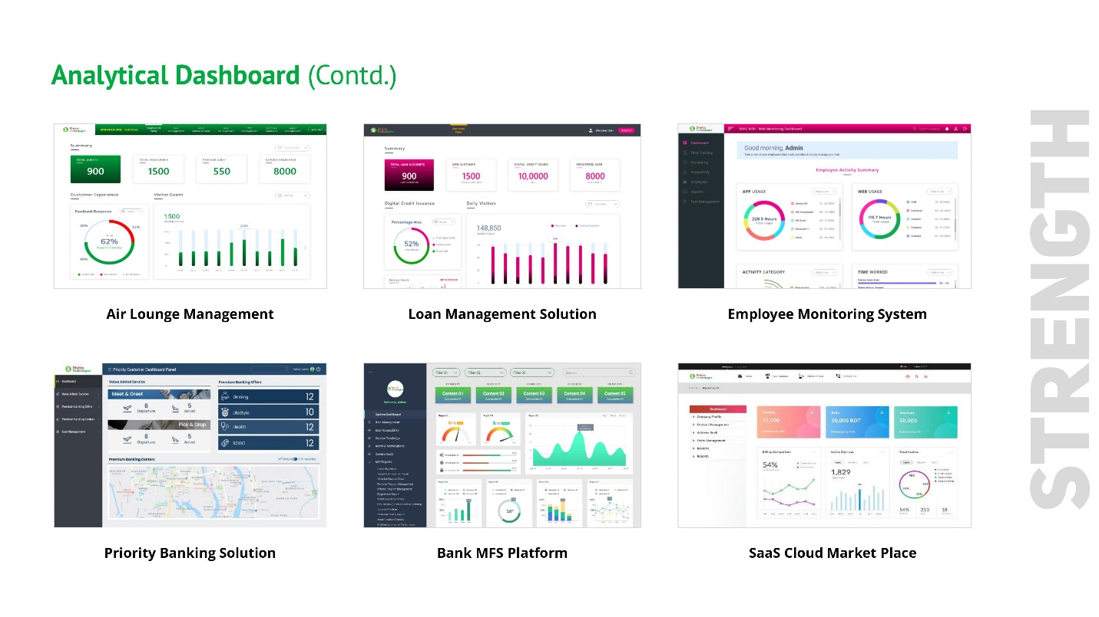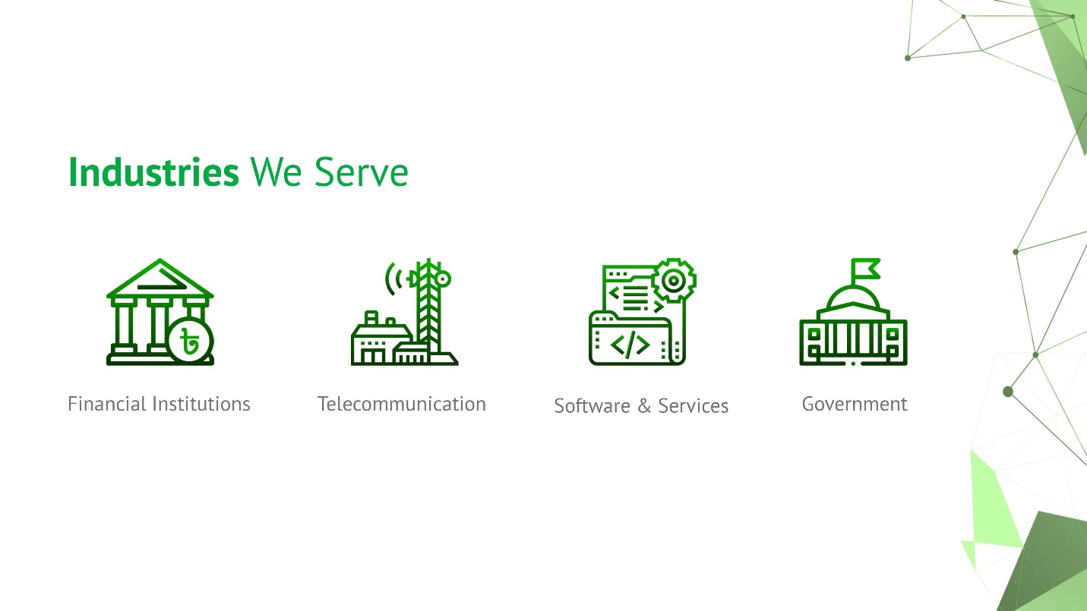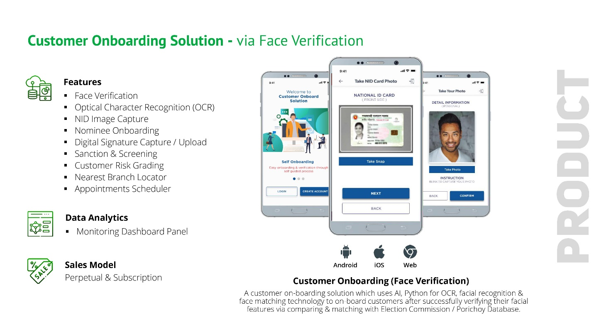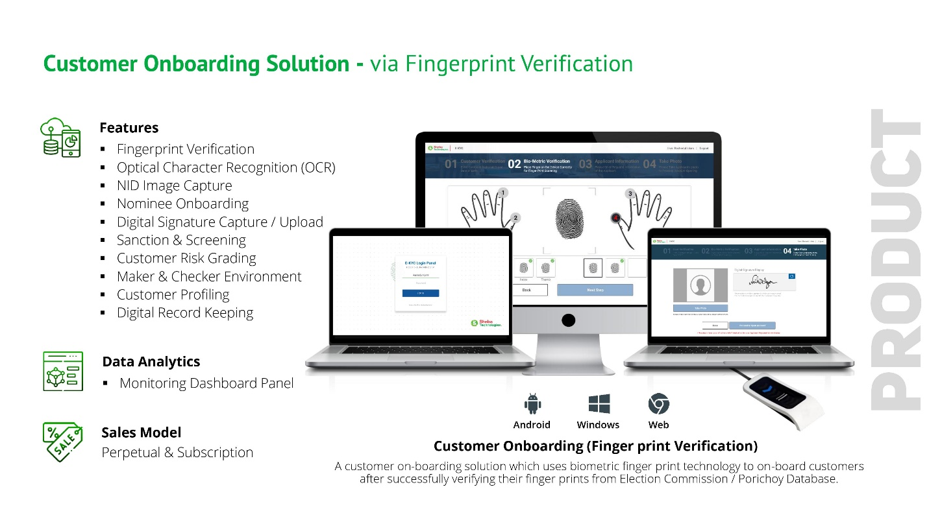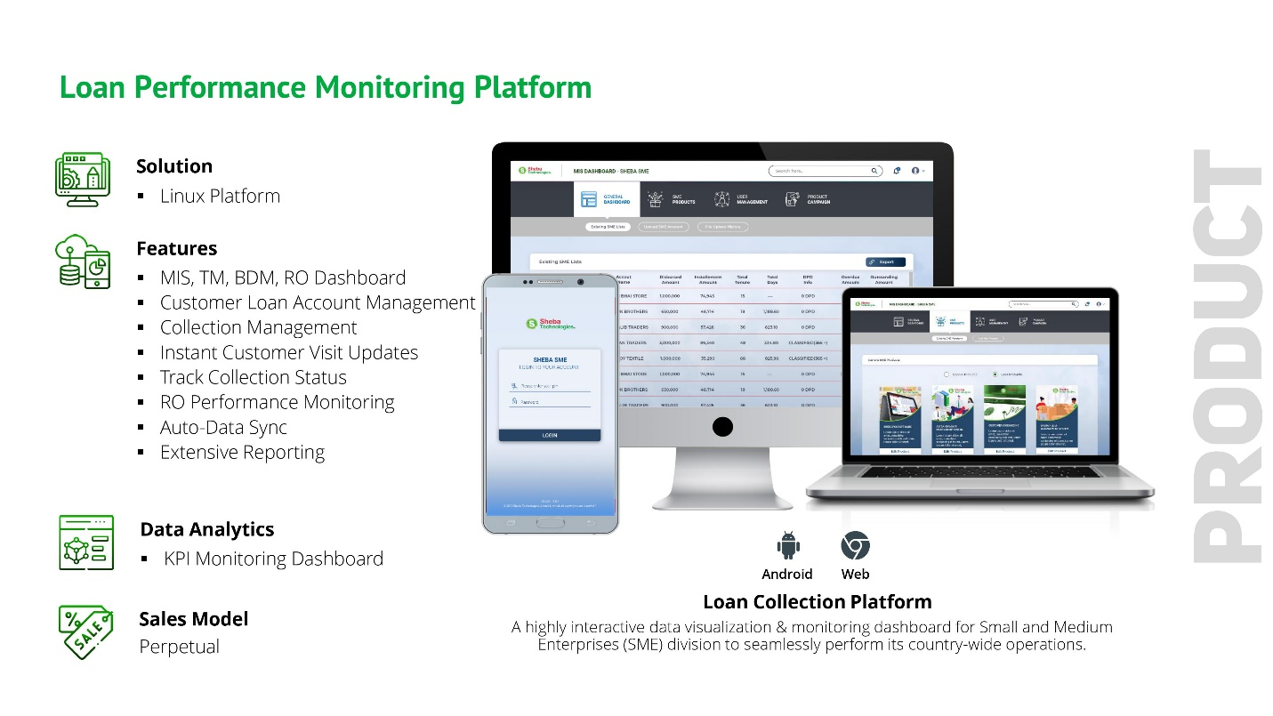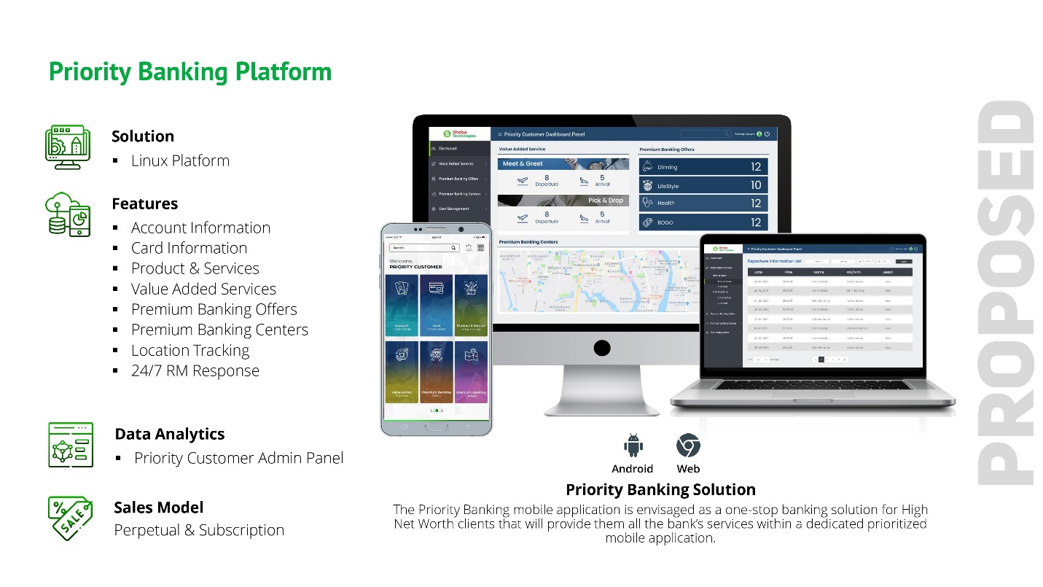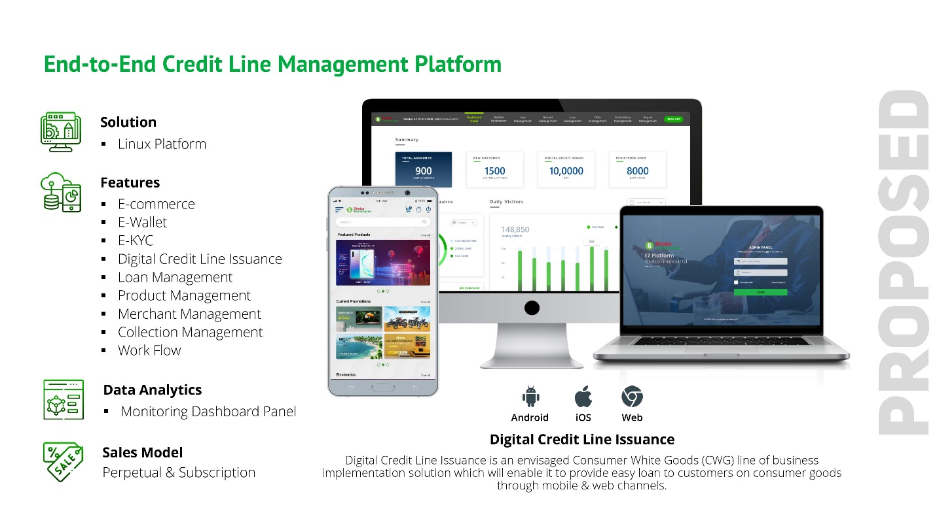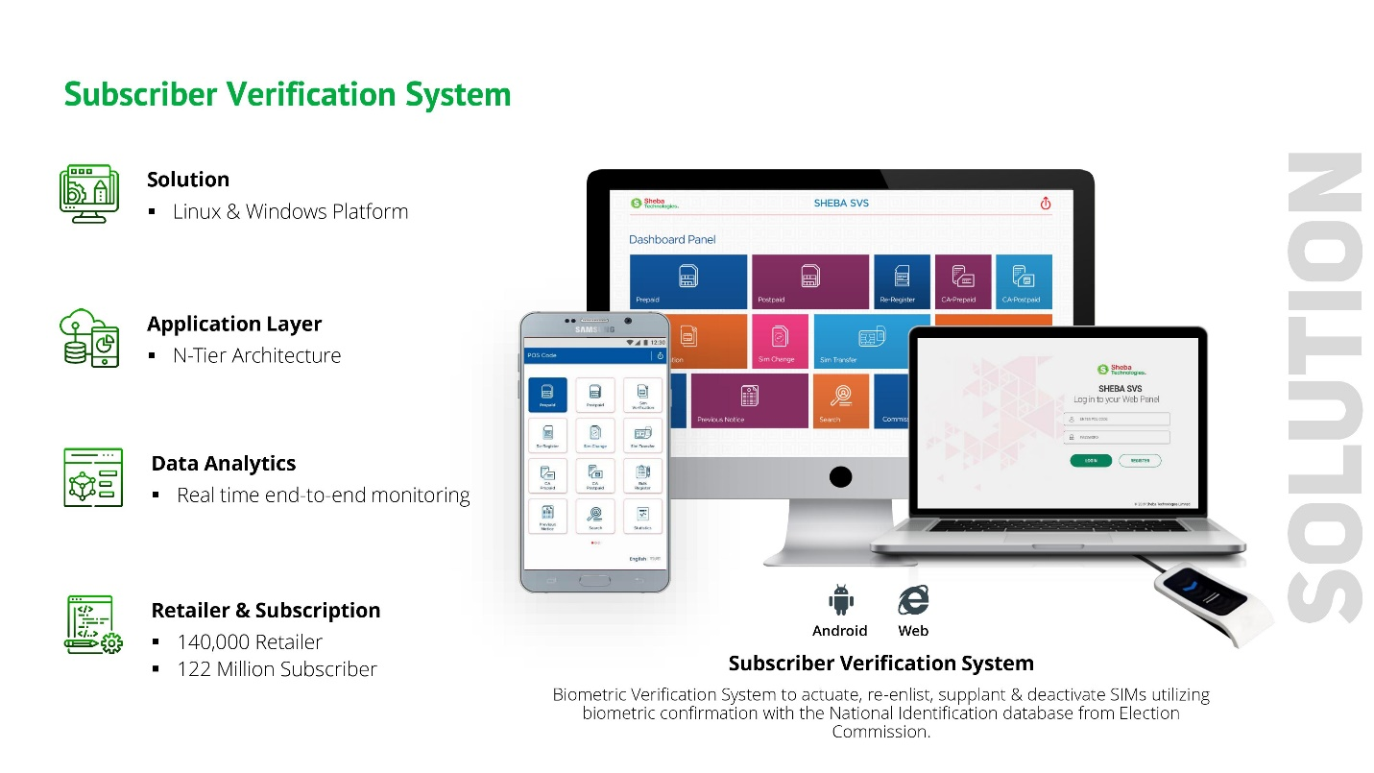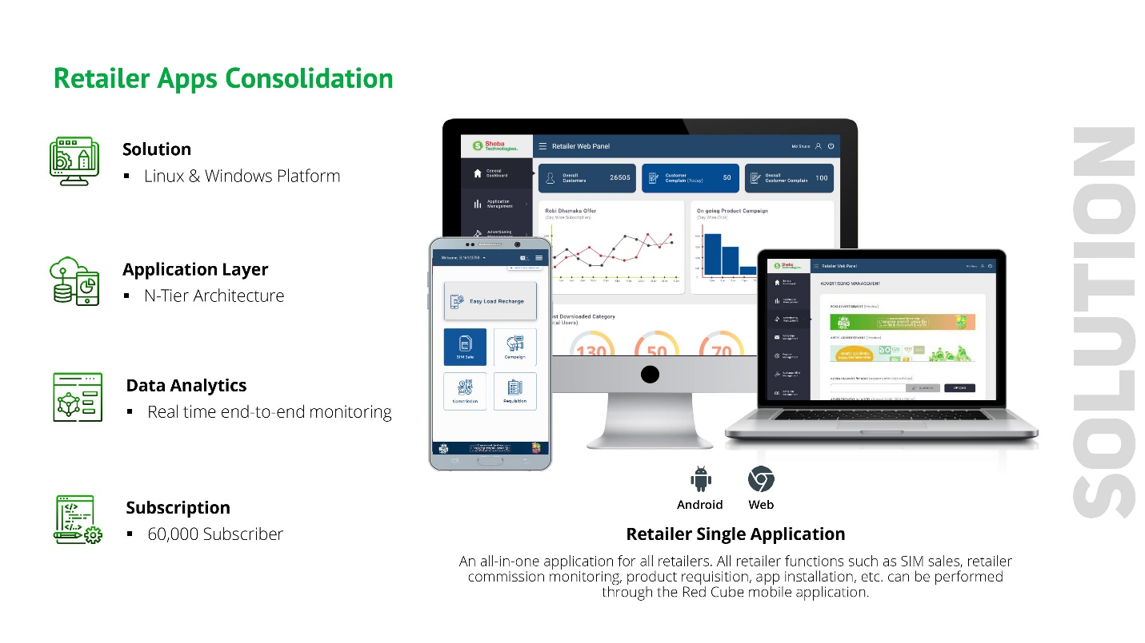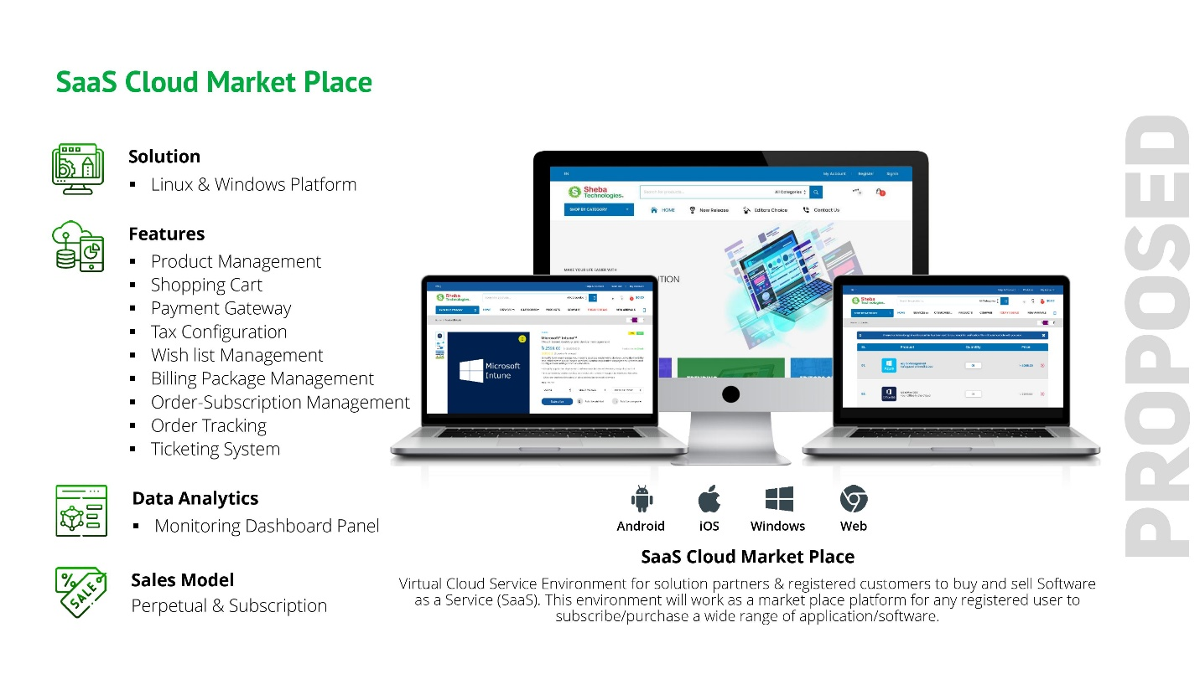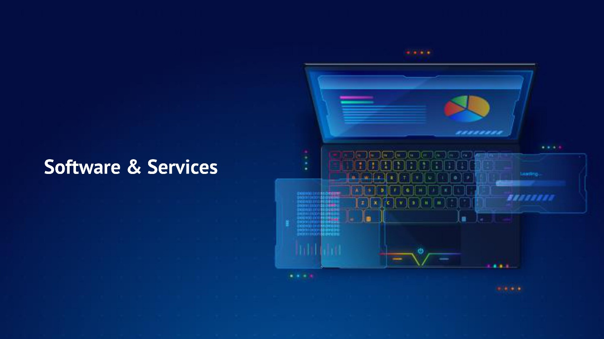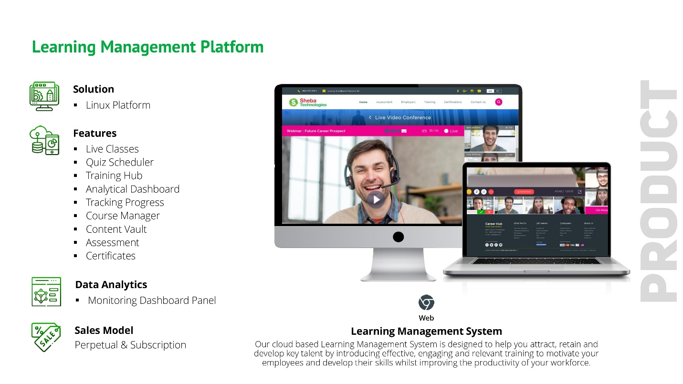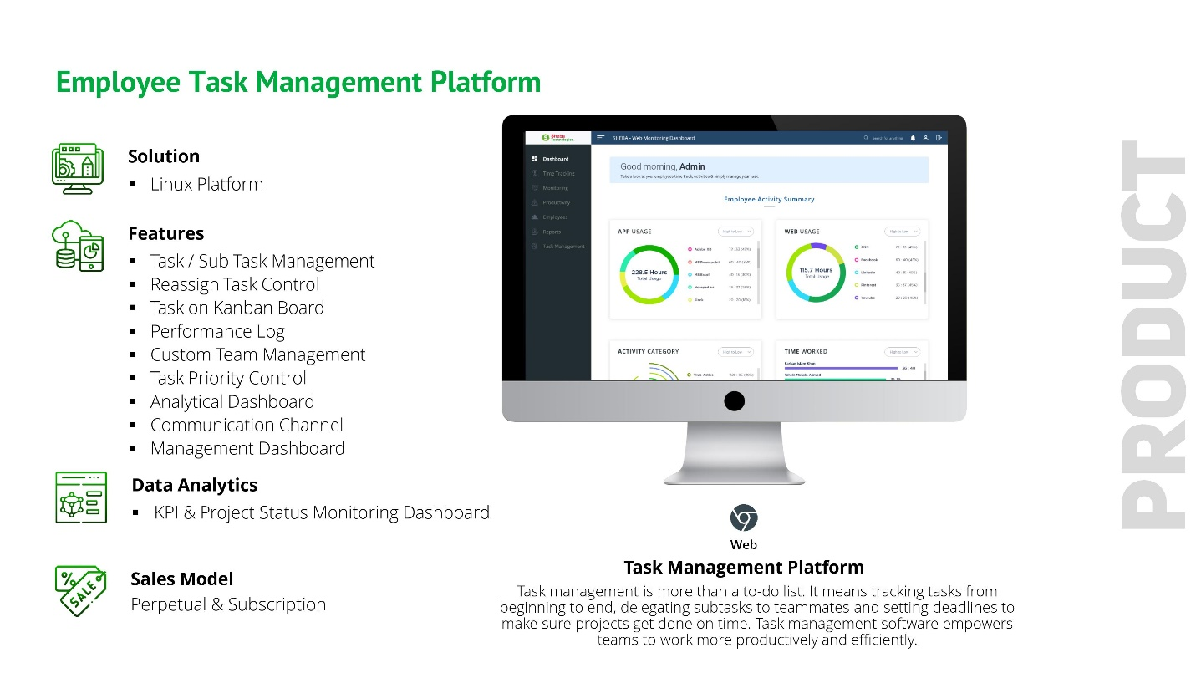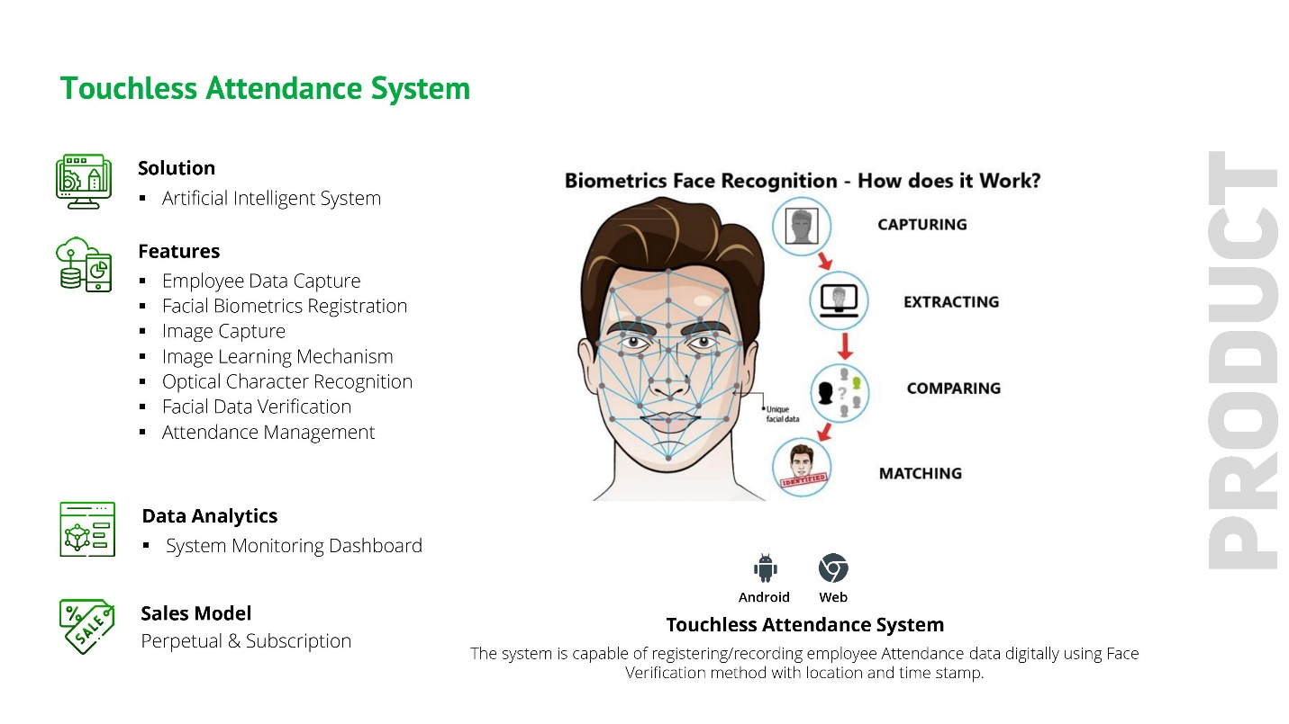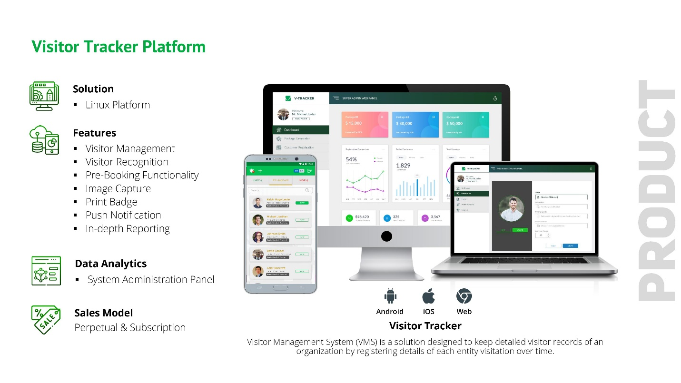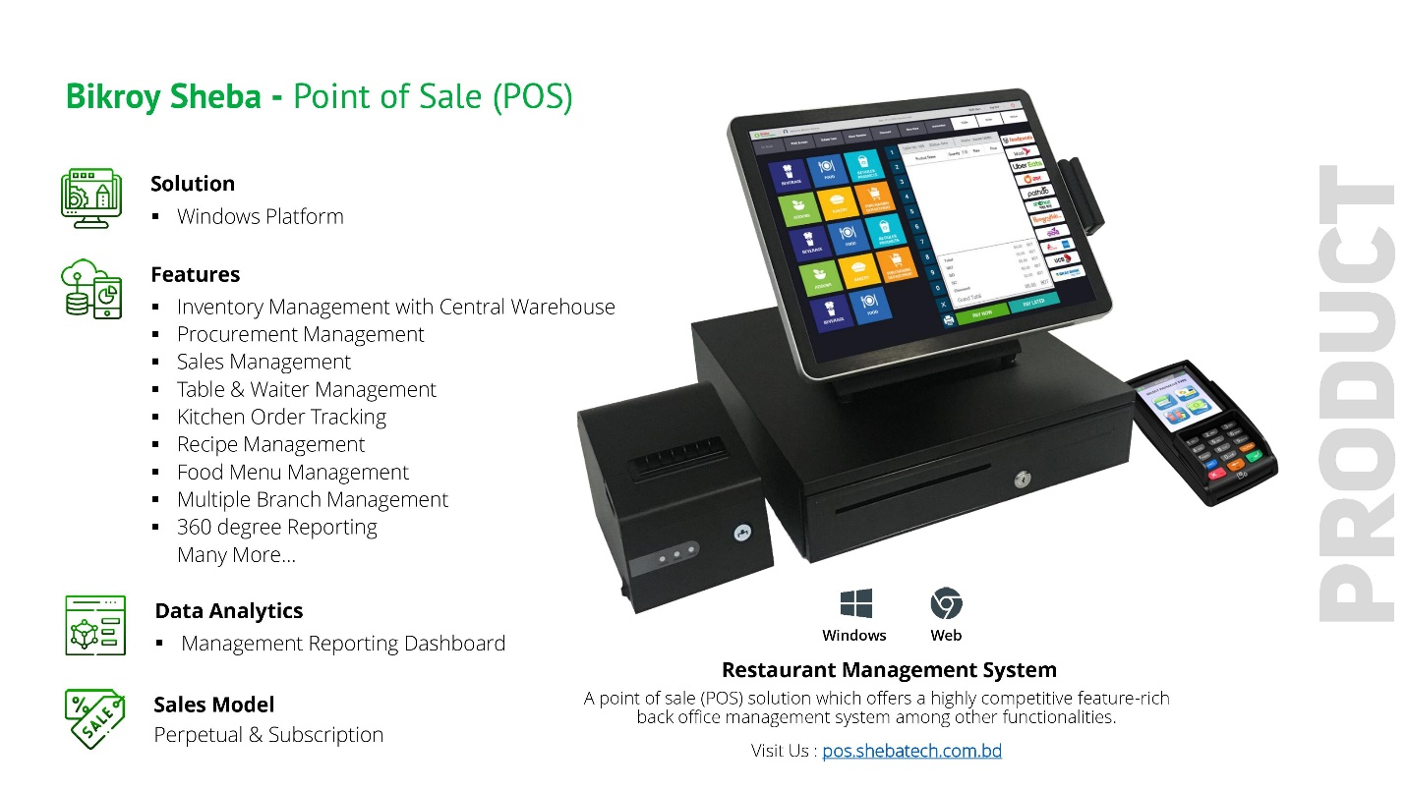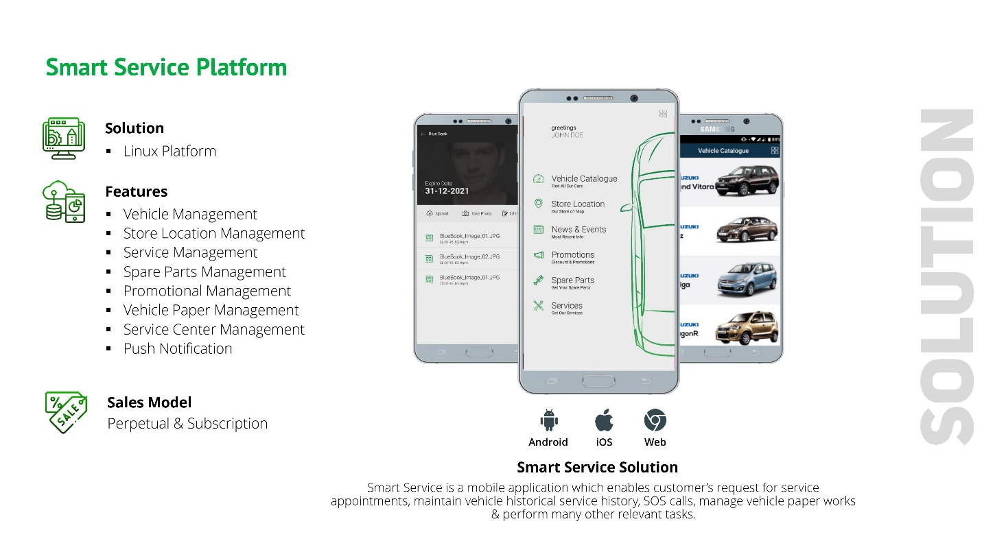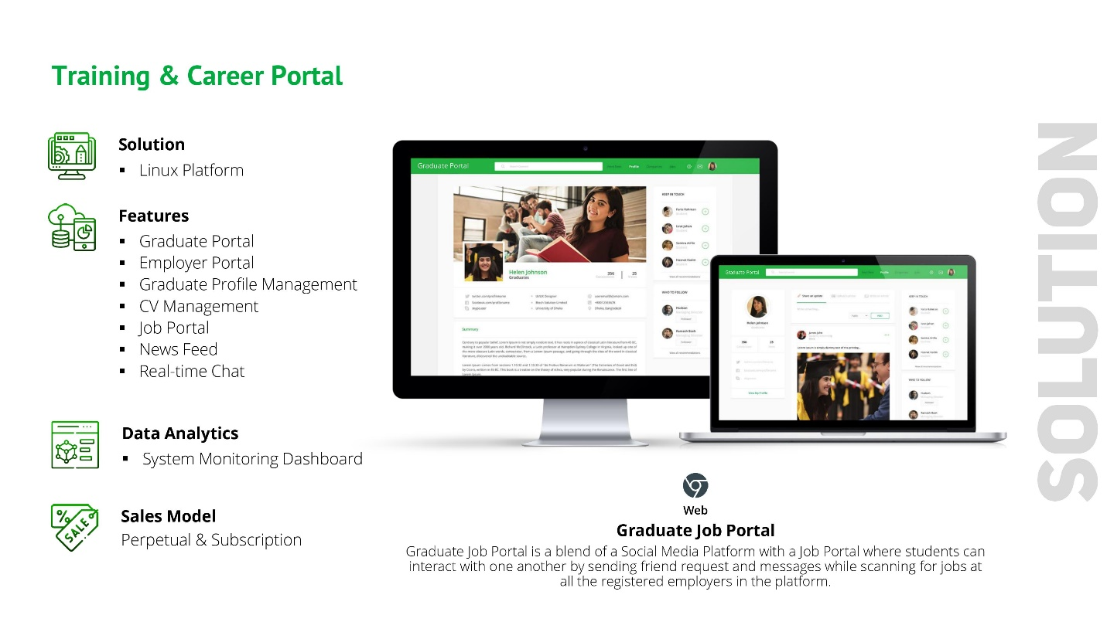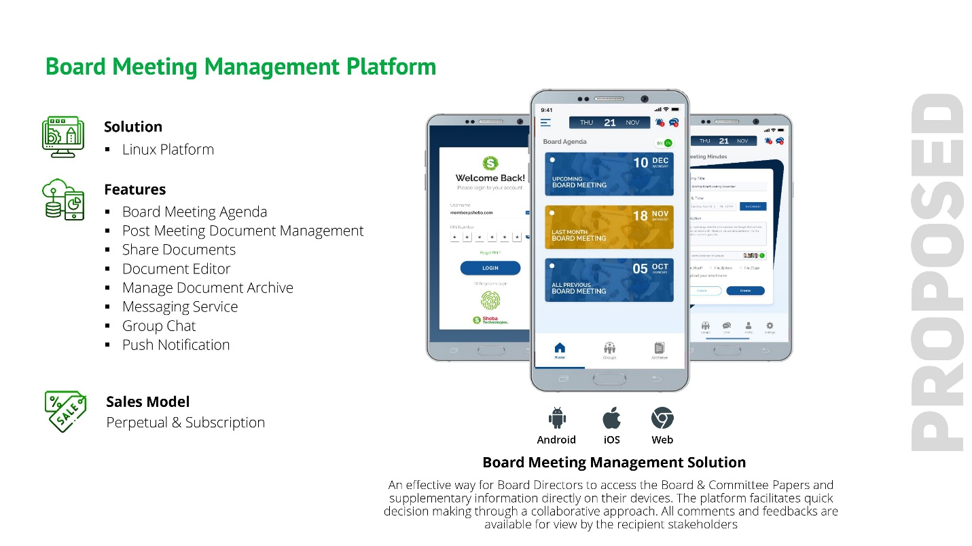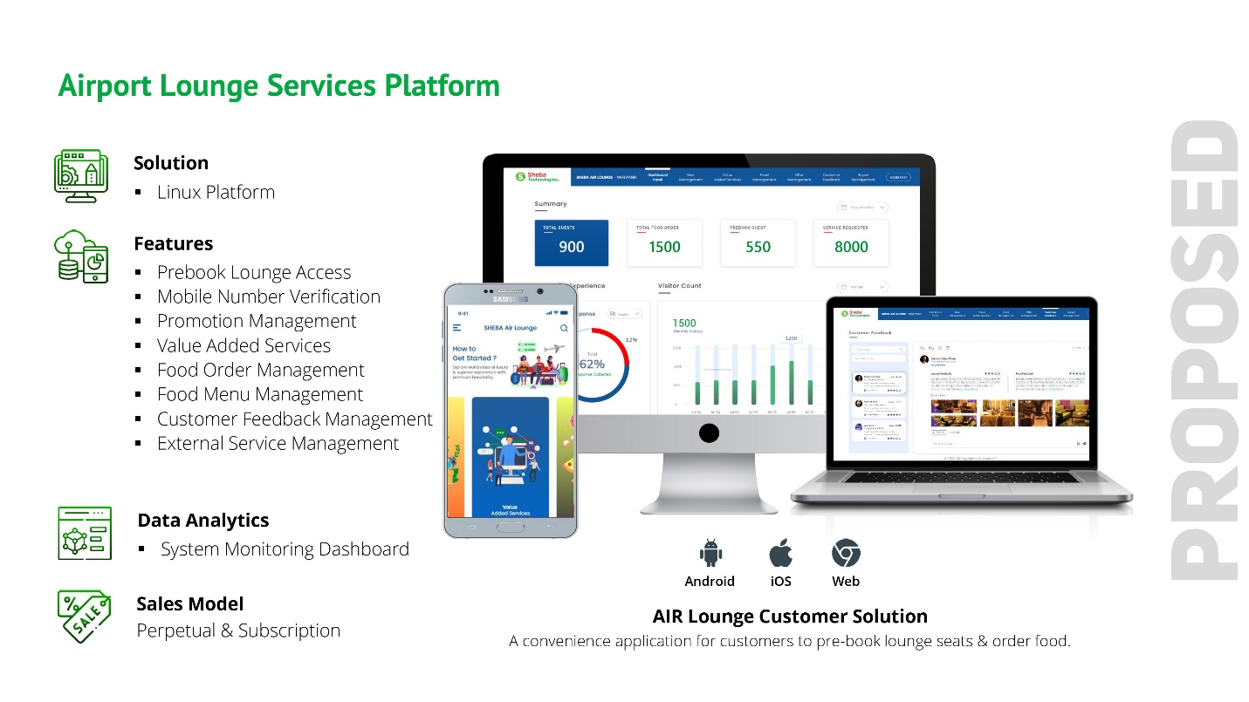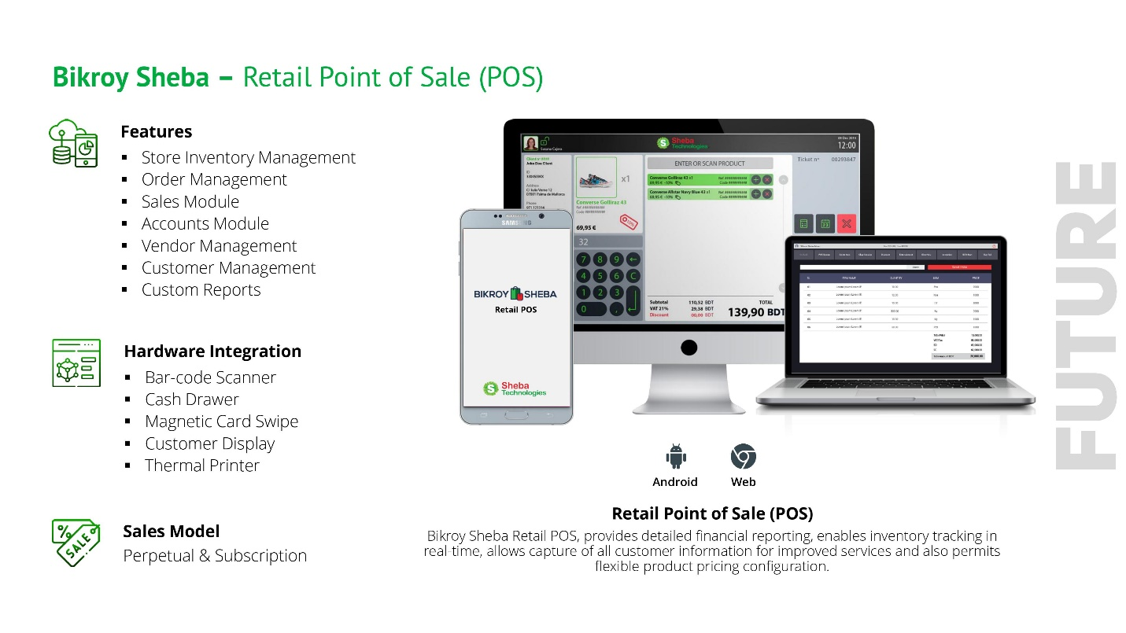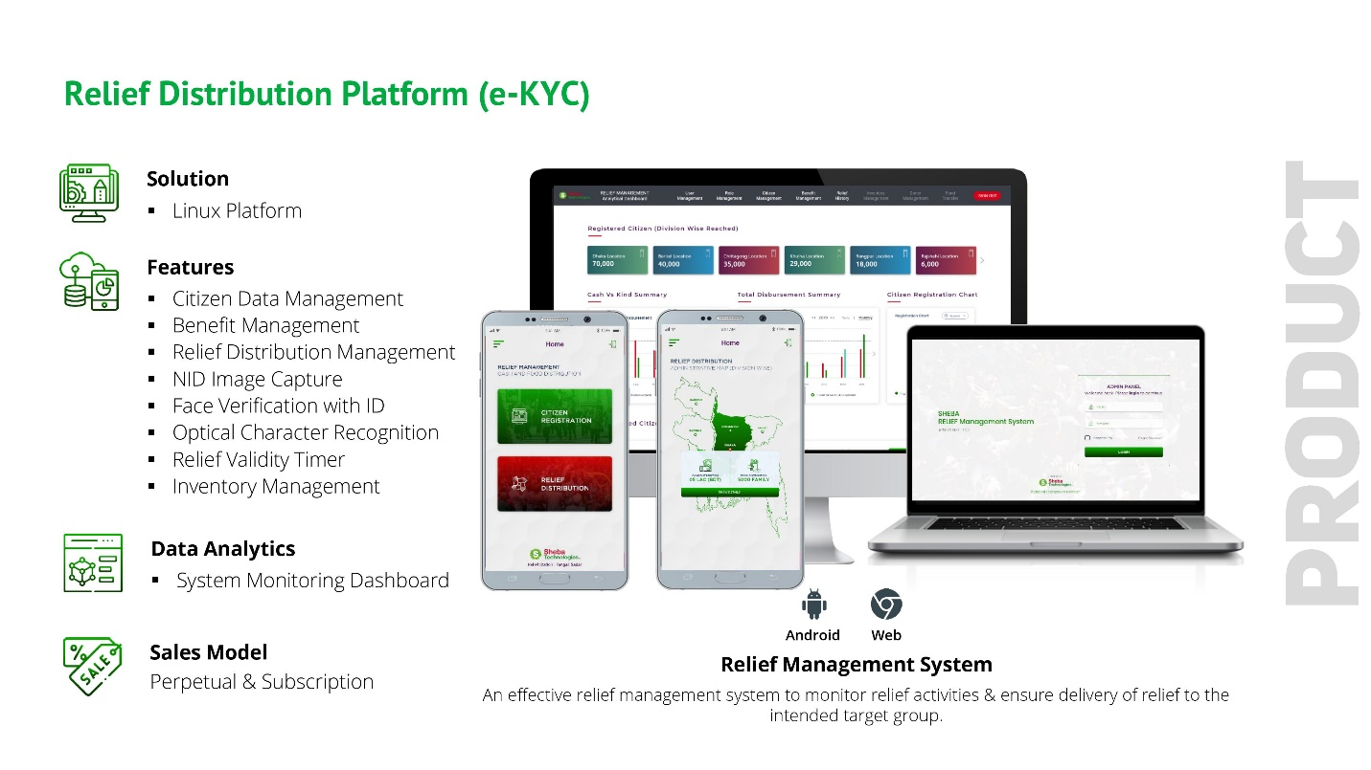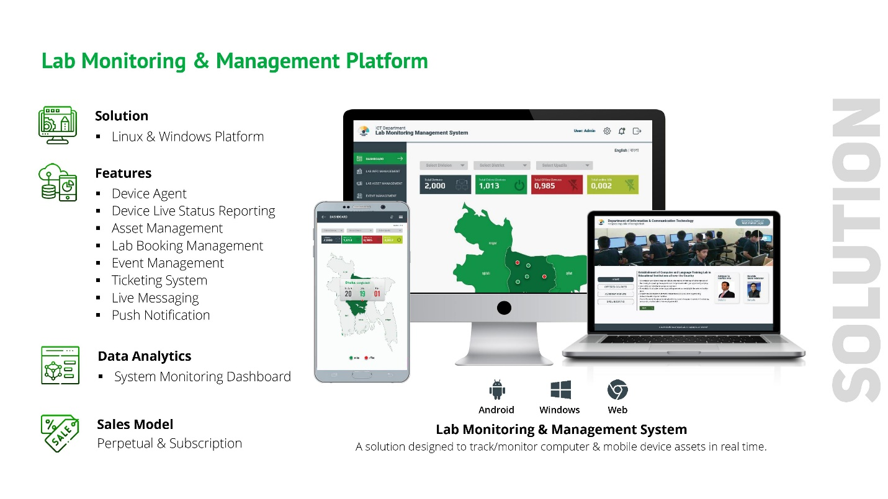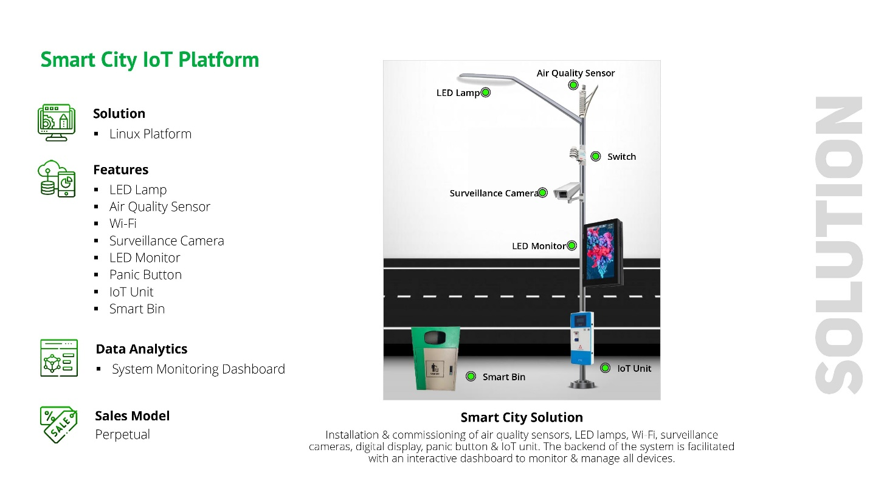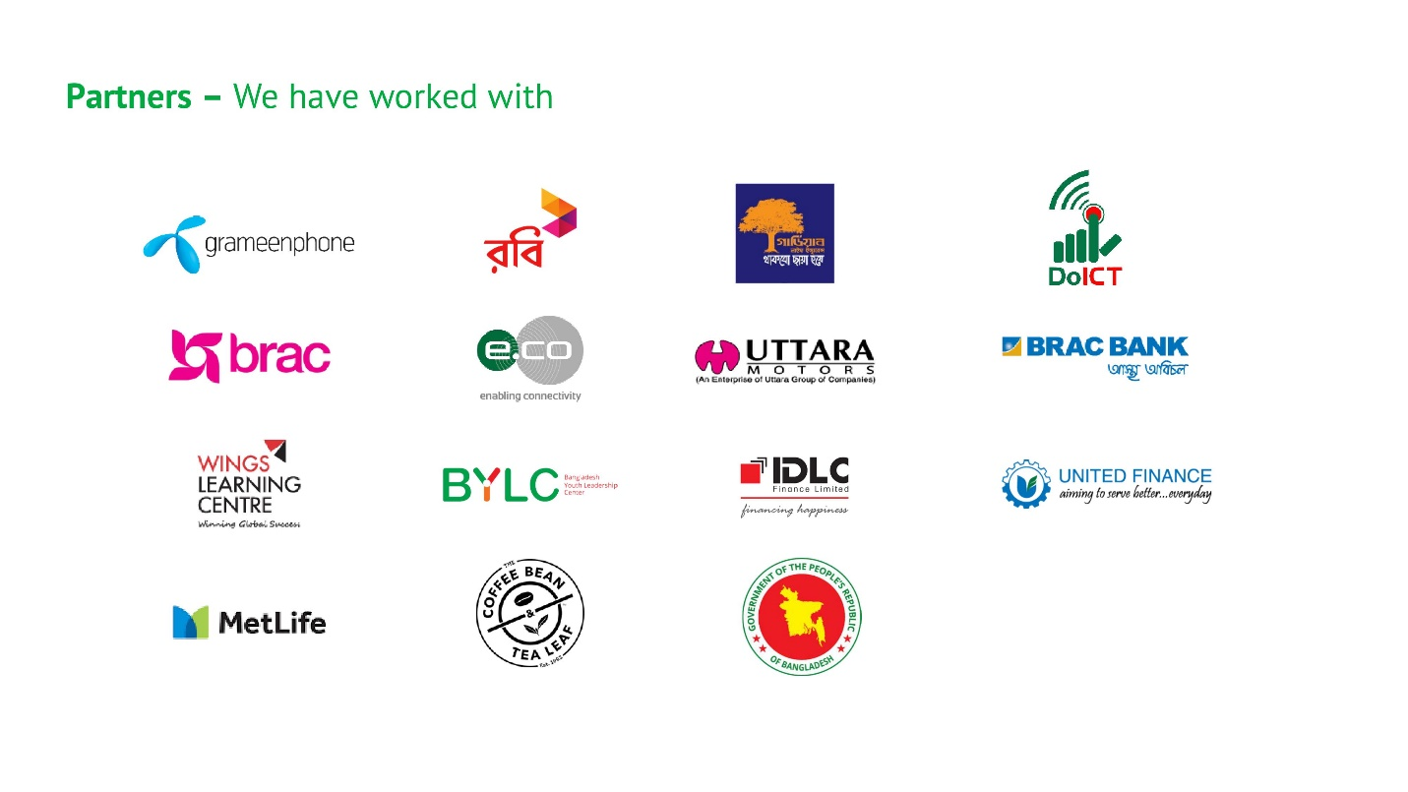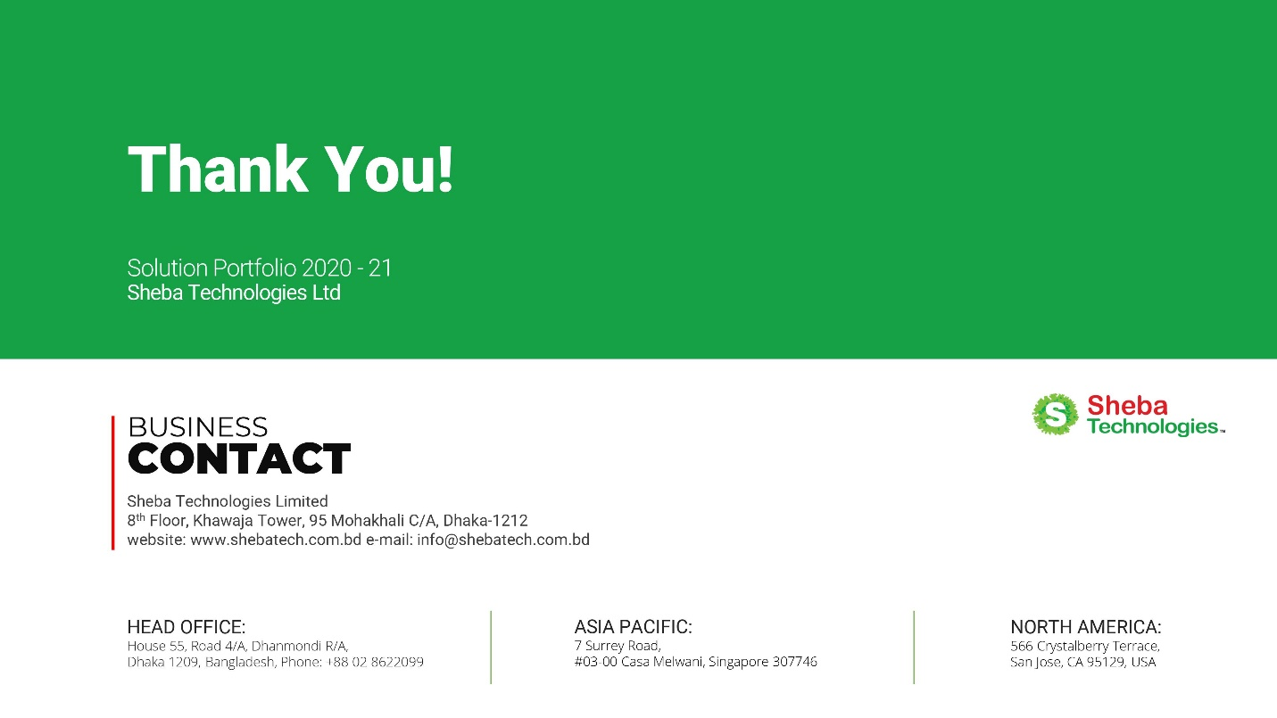

# **Experiences of the Firm in Key Operating Areas**

| **SL#** | **Software’s/Products Name** | **Clients Name & Address** |
| --- | --- | --- |
|  | **BRAC Artificial Insemination (ERP)**  **Project Background:**  This project outlines the software solution to manage the end-to-end business operation for AI Enterprise. The solution will include a mobile application and a web application to cover the whole AI business management ecosystem. Both of the application will cover from sales operation, bull rearing, production & inventory tracking to finance and human resource management. Moreover, this solution will help collect data and use those collected information to take smart decisions and improve productivity, reduce human error and enhance enterprise performance.  ***\*\*Solution provisions Inventory Management functionalitites\*\**** | **Client Name:** BRAC  **Address:** BRAC Centre, 75 Mohakhali, Dhaka-1212, Bangladesh |
|  | **Restaurant Point of Sale**  **Primary Functionalities:**   * Front Office Point of Sale; * Stock and Inventory Management; * Purchase Management; * Kitchen Management; * Customer Display; * Device Integration; * Report Generation;   ***\*\*Solution provisions Inventory Management functionalitites\*\**** | **Client Name: The** Coffee Bean & Tea Leaf  **Address:** House No 11/A, Road 117, Gulshan 2, Dhaka 1212 |
|  | **BRAC Online Careerhub LEARNING MANAGEMENT PLATFORM** | **Client Name:** BRAC  **Address:** BRAC Centre, 75 Mohakhali, Dhaka-1212, Bangladesh |
|  | **BRAC Task Management Platform** | **Client Name:** BRAC  **Address:** BRAC Centre, 75 Mohakhali, Dhaka-1212, Bangladesh |
|  | **EKYC Application** | **Client Name:** IDLC Finance Limited  **Address:** Bay’s Galleria (1st Floor), 57 Gulshan Avenue, Dhaka 1212, Bangladesh |
|  | **EKYC Application** | **Client Name:** United Finance Limited  **Address:** Camellia House,, 22 Kazi Nazrul Islam Avenue, Dhaka-1000. |
|  | **EKYC Application** | **Client Name:** Guardian Life Insurance  **Address:** Police Plaza Concord (13th Floor), Tower- 02,  Plot # 02, Road # 144, Gulshan Avenue, Dhaka- 1212. |
|  | **EKYC Application** | **Client Name:** Metlife Bangladesh  **Address:** Alico Building, 18-20 Motijheel, C/A Dilkusha Rd, Dhaka 1000 |
|  | **Bio-Metric Verification Solution (EKYC)** | **Client Name:** GrameenPhone Limited  **Address:** GP House, Bashundhara, Baridhara, Dhaka 1229 |
|  | **Robi Subscriber Verification System (EKYC)** | **Client Name:** Robi Axiata Limited  **Address:** Robi Corporate Office, 53, Gulshan South Avenue, Gulshan-1, Dhaka-1212 |
|  | **Mobile Device Management solution** | **Client Name:** GrameenPhone Limited  **Address:** GP House, Bashundhara, Baridhara, Dhaka 1229 |
|  | **Robi Single Application (Red Cube)** | **Client Name:** Robi Axiata Limited  **Address:** Robi Corporate Office, 53, Gulshan South Avenue, Gulshan-1, Dhaka-1212 |
|  | **Uttara Motors Smart Service** | **Client Name:** Uttara Motors Ltd.  **Address:** H. No102, Uttara Center, Shaheed Tajuddin Ahmed Ave, Dhaka 1208 |
|  | **BYLC Graduate Portal** | **Client Name:** Bangladesh Youth Leadership Center (BYLC)  **Address:** Plot-3 Road No. 20, Block J Baridhara, Dhaka 1212 |
|  | **Robi Enterprise Resource locator** | **Client Name:** Robi Axiata Limited  **Address:** Robi Corporate Office, 53, Gulshan South Avenue, Gulshan-1, Dhaka-1212 |

# **Financial Capacity of the Firm**

**Last 03 Years Audited Financial Report:**

|  |
| --- |
| **2016-2017** |
|  |
|  |
|  |
|  |
|  |
|  |
|  |
|  |
|  |
|  |

|  |
| --- |
| **2017-2018** |
|  |
|  |
|  |
|  |
|  |
|  |
|  |
|  |
|  |
|  |
| **2018-2019** |
|  |
|  |
|  |
|  |
|  |
|  |
|  |
|  |
|  |
| **2019-2020** |
|  |
|  |
|  |
|  |
|  |
|  |
|  |
|  |
|  |

# **Organizational Capability of the Firm**

|  |  |
| --- | --- |
| **Name** | **Farhan Islam** |
| Designation | Head of Business Operations |
| Years of experience | 16 years + |
| Technology | IT Systems, Security, Architecture, Telecom Infrastructure, Datacom, Project Managment, Product Management |
| Degree | B.Sc. (Hons) in Computer Science, University of Portsmouth, United Kingdom |
| Short Description | **Farhan Islam** is working as a Head of Business Operations for Sheba Technologies Limited. He has completed his B.Sc. (Hons) Computer Science from University of Portsmouth, United Kingdom. He has gathered extensive experience of over 16 + years in diversified fields of ICT as Software Developer, Technical Writer, Systems Analyst and Project Manager both in United Kingdom & in Bangladesh. Developed in-depth knowledge on Software development life cycle, help documentations & white papers for software developers. Recognized for translating technical information into easy to understand English. Committed to collaborate with Clients & Software development team in order to maintain smooth communication & also to provide defect free solutions. |

|  |  |
| --- | --- |
| **Name** | **Somael Kabir** |
| Designation | CTO |
| Years of experience | 16 years + |
| Technology | IT Systems, Security, Architecture, Telecom Infrastructure, Datacom, Project Management |
| Certification | CEH,C|CISO,RHCVA,RHCEv5 |
| Degree | B.Sc. in CSE, East West University |
| Short Description | 16+ years of experience in managing telecom billing operations, ICT network, systems and databases. In-depth knowledge and experience in infrastructure planning, capacity analysis, system implementation. Handle regulatory and corporate affairs. Vendor management and business plan analysis. |
| Functional Area Expertise | Self/assisted on-boarding, data capture, identity verification, integration, system security, reporting, cross channel platform development, system architechture and mobile app development. |

|  |  |
| --- | --- |
| **Name** | **Mujahidul Islam** |
| Designation | Senior System Analyst |
| Years of experience | 12 years + |
| Database | Microsoft SQL Server 2000 to 2016, MSSQL DB Clustering, Oracle 10g, MySQL, Project |
| Reporting Tools | Microsoft BI (SSRS, SSIS), QlikView, Crystal Reports. |
| Language | PL/SQL, Database Programming |
| Degree | B.Sc. in CSE |
| Short Description | Worked on System Analysis and Design, Requirements analysis as well as ensure the synchronization of business process and system development in Renowned Groups, IT Enabled Firms. Developed interactive dashboards and reports in different Business Intelligence tools. Also worked in several RDBMS including DB programming and Administration. |

|  |  |
| --- | --- |
| **Name** | **Md. Shafiqur Rahman** |
| Designation | Senior Software Developer |
| Years of experience | 10 years + |
| Language | PhP, ASP .NET |
| Scripting language | node js, Vue js, JavaScript, jquery |
| Database | Sql Server 2008, 2014, Oracle 10g, 12c, MySQL |
| Version control tool | TortoiseSVN, Git, TFS |
| Degree | M.Sc. in IT |
| Short Description | 10+ years of software development experience. Currently working as a Senior software engineer. Have more than 7 years of diversified experience in the field of ICT. Worked for Renowned ICT industry in Bangladesh. Extensive knowledge on Enterprise Appications, ERP, CRM System, Telecom Billing Solution. |

|  |  |
| --- | --- |
| **Name** | **Md. Ishtiak Harun Shovon** |
| Designation | Software Engineer |
| Years of experience | 3 Years+ |
| Technology | PHP- Laravel, React JS, Python |
| Degree | B.Sc. in CSE |
| Short Description | 3+ years of full stack application development experience. |

|  |  |
| --- | --- |
| **Name** | **Farzan Hossain Shaikat** |
| Designation | Software Engineer |
| Years of experience | 4 Years+ |
| Technology | PHP- Laravel, React JS, Python |
| Degree | B.Sc. in CSE |
| Short Description | 4+ years of full stack application development experience. |

|  |  |
| --- | --- |
| **Name** | **Md. Mahedi Hasan** |
| Designation | Software Engineer |
| Years of experience | 4 years + |
| Technology | PHP- Laravel, React JS, Vue JS, Python, Wordpress |
| Degree | B.Sc. in CSE |
| Short Description | 4+ years of application development experience. |

|  |  |
| --- | --- |
| **Name** | **Abdullah Hel Azmain** |
| Designation | Junior Software Engineer |
| Years of experience | 3 years + |
| Technology | PHP- Laravel, React JS, Python |
| Degree | B.Sc. in CSE |
| Short Description | 3+ years of application development experience. |

|  |  |
| --- | --- |
| **Name** | **Tayab Khan** |
| Designation | Head of Infrastructure |
| Years of experience | 12 years + |
| Technology | IT Systems, Security, Architecture, Telecom Infrastructure, Datacom. |
| Degree | B.Sc. in CSE |
| Training | Cyber Security Concepts & Principles  RHCSA and RHCE  CCNA |
| Short Description | 12+ years of core IT, infrastructure and cyber security systems experience. |

|  |  |
| --- | --- |
| **Name** | **Md Sadi Arman** |
| Designation | Project Manager (Technical) |
| Years of experience | 6 years + |
| Technology | Planning and forecasting, Risk management, Budgeting, Tracking and monitoring, Project management methodologies (Agile, Waterfall, Kanban, etc.), Meeting facilitation, Subject matter expertise, Project management software (Jira, Trello, Asana, etc.). |
| Degree | BSc in CSE, Eastern University |
| Short Description | Experienced Project Manager with a demonstrated history of working in the Software Industry, Real Estate, and Telemarketing. |

|  |  |
| --- | --- |
| **Name** | **MD. Saiful Islam** |
| Designation | Assistant Manager (IT) |
| Years of experience | 7 years + |
| Technology | IT Systems, Security, Architecture, Telecom Infrastructure, Datacom. |
| Degree | B.Sc. in CSE |
| Short Description | 7+ years of core IT, infrastructure and cyber security systems experience. |

|  |  |
| --- | --- |
| **Name** | **A.K.M Ariful Islam Shimul** |
| Designation | Lead Application Developer |
| Years of experience | 8 years + |
| Technology | IT Systems, Security, Architecture, BLL. |
| Degree | B.Sc. in CSE, MSC in CSE |
| Short Description | 8+ years of application development experience. |

|  |  |
| --- | --- |
| **Name** | **A. M. Rafat Rahman** |
| Designation | UI/UX Expert |
| Years of experience | 6 years + |
| Technology | UI, UX, Mock-up and prototype development. |
| Degree | MSC in ICT |
| Short Description | 6+ years of application UI/UX development experience. |

|  |  |
| --- | --- |
| **Name** | **Moktar Hossain** |
| Designation | Senior Mobile Developer |
| Years of experience | 7 years + |
| Language | PhP, ASP .NET, SWIFT, JAVA. |
| Scripting language | node js, Vue js, JavaScript, jquery |
| Database | Sql Server 2008, 2014, Oracle 10g, 12c, MySQL |
| Version control tool | TortoiseSVN, Git, TFS |
| Degree | M.Sc. in IT |
| Short Description | 7+ years of Android & IOS development experience. |

|  |  |
| --- | --- |
| **Name** | **Saiful Islam Shojib** |
| Designation | Mobile App Developer |
| Years of experience | 7 years + |
| Language | PhP, ASP .NET, SWIFT, JAVA |
| Scripting language | node js, Vue js, JavaScript, jquery |
| Database | Sql Server 2008, 2014, Oracle 10g, 12c, MySQL |
| Version control tool | TortoiseSVN, Git, TFS |
| Degree | BSc. in CSE |
| Short Description | 7+ years of Android & IOS development experience. |

|  |  |
| --- | --- |
| **Name** | **Rakib Hasan** |
| Designation | Mobile App Developer |
| Years of experience | 3 years + |
| Language | SWIFT, JAVA |
| Degree | BSc. in CSE |
| Short Description | 3+ years of Android & IOS development experience. |

|  |  |
| --- | --- |
| **Name** | **Rezwanul Reaz** |
| Designation | Software Developer Developer |
| Years of experience | 7 years + |
| Language | PhP, ASP .NET |
| Scripting language | node js, Vue js, JavaScript, jquery |
| Database | Sql Server 2008, 2014, Oracle 10g, 12c, MySQL |
| Version control tool | TortoiseSVN, Git, TFS |
| Degree | BSC. in CSE |
| Short Description | 7+ years of software development experience. |

|  |  |
| --- | --- |
| **Name** | **Fahima Chowdhury** |
| Designation | Software Developer Developer |
| Years of experience | 4 years + |
| Language | PhP, ASP .NET |
| Scripting language | node js, Vue js, JavaScript, jquery |
| Database | Sql Server 2008, 2014, Oracle 10g, 12c, MySQL |
| Version control tool | TortoiseSVN, Git, TFS |
| Degree | BSC. in CSE |
| Short Description | 4+ years of software development experience. |

|  |  |
| --- | --- |
| **Name** | **Nipun Ferdous** |
| Designation | Business Analsyt |
| Years of experience | 3 years+ |
| Specialization | * Documentation-SRS, BRS, PRD, User Story, User Manual, Technical Proposal, Business Plan, Test Report, Bug Report, RTM; * Software Process Diagramming: Activity Diagram, Sequence Diagram, DFD, Use Case Diagram, Class Diagram; * Solution Demonstration; * Software Quality Assuarance; |
| Degree | B.Sc. in Computer Science, BRAC University |
| Short Description | 3 years+ experience in fields of Product Analysis, IT Business Analysis, Software Testing and Quality Assuarance. |

|  |  |
| --- | --- |
| **Name** | **Ajfar Chowdhury** |
| Designation | Business Analsyt |
| Years of experience | 2 years+ |
| Specialization | * Documentation-SRS, BRS, PRD, User Story, User Manual, Technical Proposal, Business Plan; * Software Process Diagramming: Activity Diagram, Sequence Diagram, DFD, Use Case Diagram, Class Diagram; * Solution Demonstration; |
| Degree | B.Sc. in Computer Science |
| Short Description | 2 years+ experience in fields of Product Analysis, IT Business Analysis |

|  |  |
| --- | --- |
| **Name** | **Salman Kabir Shuvo** |
| Designation | UI/UX Expert |
| Years of experience | 3 years + |
| Technology | UI, UX, Mock-up and prototype development. |
| Degree | BSc in CSE |
| Short Description | 3+ years of application UI/UX development experience. |

|  |  |
| --- | --- |
| **Name** | **MD Jeshad** |
| Designation | Tester & QA |
| Years of experience | 3 years + |
| Technology | Testing, QA & documentation |
| Degree | BSc in CSE |
| Short Description | 3+ years of application UI/UX development experience. |

|  |  |
| --- | --- |
| **Name** | **Tajid Hasan** |
| Designation | Senior ICT Engineer |
| Years of experience | 10 years + |
| Technology | IT Systems, Security, Architecture, Telecom Infrastructure, Datacom. |
| Degree | B.Sc. in CSE |
| Training | Cyber Security Concepts & Principles  RHCSA and RHCE  CCNA |
| Short Description | 10+ years of core IT, infrastructure and cyber security systems experience. |

|  |  |
| --- | --- |
| **Name** | **SNA Nilim** |
| Designation | Software Developer |
| Years of experience | 4 years + |
| Technology | Machine Learning, AI & R&D |
| Degree | BBA, MBA |
| Short Description | 4+ years of in machine learning, AI and R&D |
| Functional Area Expertise | Machine Learning, AI & R&D |

# **Logistics Resources of the Firm**

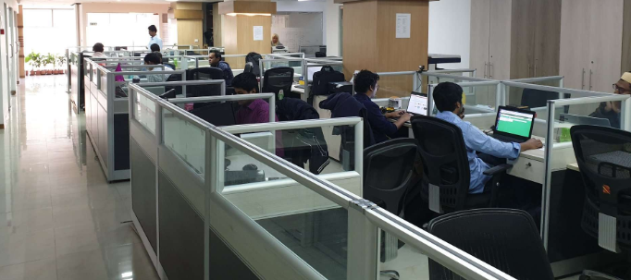The work center of Sheba Technologies Limited offers excellent environment with all modern facilities of hardware, software and networking. The total floor space is approximately 5000 sft and is equipped with a wide array of hardware including sophisticated and powerful PCs, Laptops, Laser Printers, Scanners and color printers. STL is fully equipped to provide all necessary logistic support for various Software development, training and consultancy project activities. It has all sorts of modern and up-to date computers and peripheral equipment.

STL uses modern IT equipment, servers and peripherals to accomplish its business activities which are designed to fulfill the needs of Internal and External Clients efficiently. The hardware consists of:

|  |  |  |
| --- | --- | --- |
| SL | Items | Quantity |
| 1 | Desktop PC | 26 |
| 2 | Laptop (Core i3, i5, i7) | 22 |
| 3 | Brother LaserJet Network Printer (Color) | 1 |
| 4 | HP Laserjet Network Printer | 3 |
| 5 | Scanner | 3 |
| 6 | Multi Media Projector | 2 |
| 7 | IP Telephone/ SIP Phone (AASTRA/ HUAWEI) | 15 |

**Facilities:**

Well-organized corporate office – Sheba Technologies Limited is maintaining a well-organized registered office at Khawaja Tower (8th Floor), 95 Mohakhali C/A, Dhaka, with all modern and state of the art office facilities and Data Center It's total personnel force amounts to more than 40.

|  |  |  |
| --- | --- | --- |
| Sl. No. | Description | Sq. ft. |
| 1 | Conference Room | 250 |
| 2 | Data Center | 1200 |
| 3 | Office and others | 4,350 |
| Total Floor Space | | 5,800 |

**Skill Sets:**

|  |  |  |  |
| --- | --- | --- | --- |
| Programming | Web Programming | Database | Design |
| * C# * Visual Basic * Visual C++ * Object-Oriented Analysis & Design (OOA, OOD) * Java * Android * CGI Scripts * IOS (Swift, Objective C) * Python * AI/ML * React JS, Angular JS | * ASP.Net * PHP * JSP * Java Applets | * Microsoft SQL Server * Oracle * My SQL * Maria DB | * Adobe Photoshop * Adobe Illustrator * Adobe XD * Adobe Indesign * Adobe Fireworks * Pagemaker * Corel Draw |

# **Availability of Technical Experts for Performing the Assignment**

|  |  |  |  |  |  |  |  |  |  |  |  |
| --- | --- | --- | --- | --- | --- | --- | --- | --- | --- | --- | --- |
|  | | Recent Photo of the Individual | |  | | | | | | | |
| 1 | | PROPOSED POSITION FOR  THIS PROJECT | | **Head of Business Operations** | | | | | | | |
| 2 | | NAME OF PERSON | | **Farhan Islam** | | | | | | | |
| 3 | | DATE OF BIRTH | | 19-11-1982 | | | | | | | |
| 4 | | NATIONALITY | | Bangladeshi | | | | | | | |
| 5 | | MEMBERSHIP IN PROFESSIONALSOCIETIES | | *N/A* | | | | | | | |
| 6 | | EDUCATION: | | *BSc. Computer Science,*  *University of Portsmouth, United Kingdom* | | | | | | | |
| 7 | | OTHER TRAINING | | N/A | | | | | | | |
| 8 | | LANGUAGES & DEGREE OF  PROFICIENCY | | Language | | | Speaking | | Reading | Writing | |
|  | | *English* | | | *Fluent* | | *Excellent* | *Excellent* | |
| 9 | | COUNTRIES OF WORK EXPERIENCE | | Bangladesh | | | | | | | |
| 10 | | | EMPLOYMENT RECORD |  | | | | | | | |
|  | | **EMPLOYER: 1**  **Sheba Technologies Ltd.**  <http://www.shebatech.com.bd/>  8th Floor, Khawaja Tower, 95 Mohakhali C/A, Dhaka-1212.  Position Held: **Head of Business Operations**  **Duties and Responsibilities:**   * Report to CEO on Business Development & Operations; * Collect reports on upcoming project opportunities; * Lead Technical Documentation Team; * Lead Software Quality Assurance & Software Testing Group; * Lead Business Analysts; * Taken Responsibility as Head of Software Engineering Process Group (SEPG); * Provide and support the implementation of business solutions by building relationships and partnerships with key stakeholders; identifying business needs; determining and carrying out necessary processes and practices; monitoring progress and results; recognizing and capitalizing on improvement opportunities; and adapting to competing demands, organizational changes and new responsibilities; * Monitor Project schedules, milestone completions, track all phases of the project lifecycle; * Manage Project team regularly to review project deliverables and deadlines; * Manage existing products and its upcoming feature roadmap; | | | | FROM:  **2020** | | | TO:  **Ongoing** | | |
|  | **EMPLOYER: 2**  **Sheba Technologies Ltd.**  <http://www.shebatech.com.bd/>  8th Floor, Khawaja Tower, 95 Mohakhali C/A, Dhaka-1212.  Position Held: **Senior Business Analyst**  **Duties and Responsibilities:**   * Lead UI/UX Team; * Support and align efforts to meet customer and business needs; * Manage customer relationships and expectations by developing a communication process; * Capture and clearly document business and systems requirements; * Lead or participate in multiple projects by completing and updating project documentation; managing project scope; adjusting schedules when necessary; determining daily priorities; ensuring efficient and on-time delivery of project tasks and milestones; following proper escalation paths; and managing customer and supplier relationships; * Provide project level analysis – producing required project analysis documentation (business requirements, scope matrix, use cases, sequence diagrams, future state proposals, UAT plan); * Analyze Customer Business Requirements and present them with Non-Functional Prototypes to allow them to visualize and experience the solution to be; * Create and maintain issue logs, meeting minutes, meeting schedules, project summaries and updates; * Create and maintain project schedules by developing project plans and specifications, estimating time and resources, monitoring milestone completion, tracking all phases of the project lifecycle, providing timely reporting of issues that impact project progress, coordinating actions and resolving conflicts; * Develop and execute test plans; * Support system conversions, upgrades, enhancements; * Oversee the design of new products, assisting with market trends in order to guide the design team; | | | | FROM:  **2019** | | | TO:  **2020** | | |
|  | **EMPLOYER: 3**  **Sheba Technologies Ltd.**  <http://www.shebatech.com.bd/>  8th Floor, Khawaja Tower, 95 Mohakhali C/A, Dhaka-1212.  Position Held: **Product Manager**  **Duties and Responsibilities:**   * Lead the product development process, including user research, prototyping, and business case generation while working very closely with the Technical Team; * Develop and implement product strategies consistent with company vision; * Collect and analyze feedback from customers, stakeholders and other teams to shape requirements, features and end products; * Work with senior management to create product plans and road maps; * Produce and review product requirement documents (PRD); * Ensure products release as per “Go to Market” (G2M) Strategy; * Managing the product through the delivery process, including managing key vendors / partners and influencing internal stakeholders; * Monitoring product key performance indicators and continuously improving operational delivery to maximize performance; * Preparing and conducting PoC (Proof of Concept), UAT (User Acceptance Test), User Manual, operation and quality control processes; * Continuously communicate with customers and end users to meet their expectation and minimize gap; * Recommending the nature and scope of present and future product lines by reviewing product specifications and requirements; appraising new product ideas and/or product or packaging changes; * Assessing market competition by comparing the company's product to competitors' products; * Providing source data for product line communications by defining product marketing communication objectives; * Obtaining product market share by working with sales to develop product sales strategies; * Providing information for management by preparing short-term and long-term product sales forecasts and special reports and analyses; answering questions and requests; * Facilitating inventory turnover and product availability by reviewing and adjusting inventory levels and production schedules; * Bringing new products to market by analyzing proposed product requirements and product development programs; preparing return-on-investment analyses; establishing time schedules with development; * Introduces and markets new products by developing time-integrated plans with sales, advertising, and production; * Determines product pricing by utilizing market research data; reviewing production and sales costs; anticipating volume; costing special and customized orders;   **EMPLOYER: 4**  FROM To  **2010 2016**  **SkyHigh Communications, HK Limited**  Position Held: **Partner & Chief Business Development Manager**  **Duties and Responsibilities:**   * Reaching out to interconnect with variety of other telecomm carrier’s worldwide; * Negotiating Voice Traffic Wholesale Rates as per destination and caller prefix; * Keeping Local Capacity Suppliers available at all times with numerous **E1** capacity; * Reviewing and Analyzing Call Success Rates along with Average Call durations every hour; * Troubleshooting any issues that might arise while Routing VOIP traffic from Customer To Supplier To Soft switch (VOS3000); * Maintain Monthly Traffic Revenue Accounts and Clearing Payments to all stakeholders.   FROM To **2009 2010**  **EMPLOYER: 5**  **Bangladesh Internet Press Ltd. (BIPL), Bangladesh**.  Position Held: **Manager Key Accounts & Client Relationship**  **Duties and Responsibilities:**   * Use variety of resources to scan through Prospective Tenders & create relationship with the client’s high-end authorities to find & gather in depth project related information; * Schedule & Plan Tender Participation techniques and brief in-house team member to work accordingly; * Actively participate in preparing Technical & Financial Proposal; * Work as a bridge between existing Clients and our Development Team to ensure all Projects related work are well documented & maintained as per CMMI (Level 3) standards; * Assist HR Department to scan through applicants in order to employ consultants for upcoming projects & also for any replacement in the ongoing projects; * Work closely together with the Managing Director & the top-level management officials to identify future prospects of the Company.   FROM To **2004 2005**  **EMPLOYER: 6**  **Apollo Fire detectors Limited, United Kingdom**  Position Held: **Technical Maintenance Engineer**  **Duties and Responsibilities:**   * In charge of providing maintenance support to the shop floor which consists of a wide variety of machines in the production line of fire detectors; * Also engaged partially in charge of Health and Safety from the electrical section, as to perform PAT test to make sure that all the items in use are safe to handle.   FROM To **2002 2003**  **EMPLOYER: 7**  **iCubed Technologies Ltd. United Kingdom**  Position Held: **Industrial Placement Engineer**  **Duties and Responsibilities:**   * iCubed Technologies mainly focuses on providing solutions for real time control systems in commerce and industry; * Involved in Software development, Web Applications development, Embedded Applications Testing, User Interfaces Design and Documentation. | | | | FROM:  **2016** | | | TO:  **2019** | | |

CERTIFICATION

I, the undersigned, certify that (i) I was not a former employee of the Client immediately before the submission of this proposal, and (ii) to the best of my knowledge and belief, this biodata correctly describes myself, my qualifications, and my experience. I understand that any wilful misstatement described herein may lead to my disqualification or dismissal, if engaged.  
I have been employed by **Sheba Technologies Ltd.** continuously for the last Sixty five (65) months as regular full time staff. Indicate “Yes” or “No” in the boxes below:

|  |  |  |  |  |  |  |  |  |  |  |  |  |  |  |  |
| --- | --- | --- | --- | --- | --- | --- | --- | --- | --- | --- | --- | --- | --- | --- | --- |
|  |  |  | **YES** |  |  |  | **NO** |  |  |  |  |  |  |  |  |

|  |  |
| --- | --- |
| Signature |  |
| Date of Signing | **20-11-2021**  Day / Month / Year |

|  |  |  |  |  |  |  |
| --- | --- | --- | --- | --- | --- | --- |
|  | Recent Photo of the Individual |  | | | | |
| 1 | PROPOSED POSITION FOR THIS PROJECT | **Technical Project Manager** | | | | |
| 2 | NAME OF PERSON | **Md. Sadi Arman** | | | | |
| 3 | DATE OF BIRTH | 04-02-1994 | | | | |
| 4 | NATIONALITY | Bangladeshi | | | | |
| 5 | MEMBERSHIP IN PROFESSIONALSOCIETIES | *N/A* | | | | |
| 6 | EDUCATION: | *M.Sc. in IT (2021)* | | | | |
| 7 | OTHER TRAINING | Project Management Professional; | | | | |
| 8 | LANGUAGES & DEGREE OF  PROFICIENCY | Language | Speaking | | Reading | Writing |
|  | *English* | *Native* | | *Native* | *Native* |
| 9 | COUNTRIES OF WORK EXPERIENCE | Bangladesh | | | | |
| 10 | EMPLOYMENT RECORD |  | | | | |
|  | **EMPLOYER: 1**  **Sheba Technologies Ltd.**  <http://www.shebatech.com.bd/>  8th Floor, Khawaja Tower, 95 Mohakhali C/A, Dhaka-1212.  Position Held: **Technical Project Manager**  **Duties and Responsibilities:**   * Establish and implement training processes. * Analyse, plan and develop requirements. * Assign and oversee the daily tasks of technical personnel. * Hold regular technical team meetings. * Determine and define clear deliverables, roles and responsibilities for staff members required, etc. | | | FROM:  **2021** | TO:  **Present** | |
|  | **EMPLOYER: 2**  **Nano Information Technology**  <http://www.nanoit.biz/>  Cha-88/1/B, North Badda (2nd & 3rd Floor), Badda, Dhaka, 1212, Dhaka  Position Held: **IT Project Manager**  **Duties and Responsibilities:**   * Perform Requirement analysis, * Risk Management analysis, * Compile Software Requirement Specification and other essential documents based on relevance, * Design Activity, Wireframe, user story, etc. * Initiate Project (Agile/Waterfall methodologies), * Lead team of developer and tester towards project completion, * SQA when required, * Deliver Projects to stakeholders and many more. | | | FROM:  **2019** | TO:  **2021** | |
|  |  | | |  |  | |

CERTIFICATION

I, the undersigned, certify that (i) I was not a former employee of the Client immediately before the submission of this proposal, and (ii) to the best of my knowledge and belief, this biodata correctly describes myself, my qualifications, and my experience. I understand that any wilful mis-statement described herein may lead to my disqualification or dismissal, if engaged.

I have been employed by **Sheba Technologies Ltd.** continuously for the last Thirty One (31) months as regular full time staff. Indicate “Yes” or “No” in the boxes below:

|  |  |  |  |  |  |  |  |  |  |  |  |  |  |  |  |
| --- | --- | --- | --- | --- | --- | --- | --- | --- | --- | --- | --- | --- | --- | --- | --- |
|  |  |  | **YES** |  |  |  | **NO** |  |  |  |  |  |  |  |  |

|  |  |
| --- | --- |
| Signature |  |
| Date of Signing | **20-11-2021**  Day / Month / Year |

|  |  |  |  |  |  |  |
| --- | --- | --- | --- | --- | --- | --- |
|  | Recent Photo of the Individual |  | | | | |
| 1 | PROPOSED POSITION FOR  THIS PROJECT | **Trainer**: Senior System Analyst | | | | |
| 2 | NAME OF PERSON | **Mujahidul Islam** | | | | |
| 3 | DATE OF BIRTH | 26-08-1989 | | | | |
| 4 | NATIONALITY | Bangladeshi | | | | |
| 5 | MEMBERSHIP IN PROFESSIONALSOCIETIES | *N/A* | | | | |
| 6 | EDUCATION: | *B.Sc. in CSE, Military Institute of Science and Technology(2010)* | | | | |
| 7 | OTHER TRAINING | Basics of C.F of PHP  Networking Basics | | | | |
| 8 | LANGUAGES & DEGREE OF PROFICIENCY | Language | | Speaking | Reading | Writing |
|  | *English* | | *Fluent* | *Excellent* | *Excellent* |
| 9 | COUNTRIES OF WORK EXPERIENCE | Bangladesh | | | | |
| 10 | EMPLOYMENT RECORD |  | | | | |
|  | **EMPLOYER: 1**  **Sheba Technologies Ltd.**  <http://www.shebatech.com.bd/>  8th Floor, Khawaja Tower, 95 Mohakhali C/A, Dhaka-1212.  Position Held: **Technical Project Manager / Senior System Analyst**  **Duties and Responsibilities:**   * Practitioner in Project Management, Monitor and ensure end to end Project from Analysis phase to Deployment phase. * Performing as Technical PM and Analyst for critical and major accounts of Private and Govt sector Customers to ensure successful delivery of Projects, especially for services with Telecom operators. * Creating Project Plans and Track as well. * Requirements analysis as well as ensure the synchronization of business process owners and Development Team. * Preparing Technical Proposals, BRS and SRS for Solution or Product. * Coordinate UAT, Prepare test cases, User Manual and Coordinate with Developers, Operations and QA Team. * Database Design and Practitioner in MS SQL Database Administration. * Back end Database scripting and programming like developing Stored Procedure, Triggers, Functions as per business process requirements. | | FROM:  **December, 2016** | | TO:  **Present** | |
|  | **EMPLOYER: 2**  **Transcom group**  Position Held: **System Analyst**  **Duties and Responsibilities:**   * Requirements analysis of business processes with internal stakeholders and Design accordingly. * Develop interactive dashboards and reports in QLIKVIEW and SSRS according to top Business requirements. * Develop and Extract Transform and Load (ETL) in SSIS to consolidate distributed data of 17 sister concern and 30 Sales and Distribution house. * Mobile based Order and Sales Force management system implementation and maintenance. * Developing Stored Procedure, Triggers, Functions as per business process requirements. * MS SQL Database and ERP Environment configuration. * Back end troubleshooting, Overall Monitoring of Supply Chain of daily transaction ERP. | | FROM:  **April, 2012** | | TO:  **Oct, 2016** | |
|  | **EMPLOYER: 3**  **Synesis IT**  ICT Incubator. Level 3,  BDBL Bhaban 12 Kawran Bazar.  Position Held: **Assistant Programmer**  **Duties and Responsibilities:**   * Developing Reports & designing forms in PL/SQL. * Oracle Database server configuration. * Oracle Application server configuration. * Linux installation. * Deal with the scopes of a complete ERP. * Maintenance and management of an ERP | | FROM:  **Dec, 2009** | | TO:  **March, 2012** | |

CERTIFICATION

I, the undersigned, certify that (i) I was not a former employee of the Client immediately before the submission of this proposal, and (ii) to the best of my knowledge and belief, this bio-data correctly describes myself, my qualifications, and my experience. I understand that any wilful misstatement described herein may lead to my disqualification or dismissal, if engaged.

I have been employed by **Sheba Technologies Ltd.** continuously for the last sixty three (63) months as regular full time staff. Indicate “Yes” or “No” in the boxes below:

|  |  |  |  |  |  |  |  |  |  |  |  |  |  |  |  |
| --- | --- | --- | --- | --- | --- | --- | --- | --- | --- | --- | --- | --- | --- | --- | --- |
|  |  |  | **YES** |  |  |  | **NO** |  |  |  |  |  |  |  |  |

|  |  |
| --- | --- |
| Signature |  |
| Date of Signing | **20-11-2021**  Day / Month / Year |

|  |  |  |  |  |  |  |
| --- | --- | --- | --- | --- | --- | --- |
|  | Recent Photo of the Individual |  | | | | |
| 1 | PROPOSED POSITION FOR  THIS PROJECT | **Senior Software Architect** | | | | |
| 2 | NAME OF PERSON | **MD. SHAFIQUR RAHMAN** | | | | |
| 3 | DATE OF BIRTH | 01-07-1989 | | | | |
| 4 | NATIONALITY | Bangladeshi | | | | |
| 5 | MEMBERSHIP IN PROFESSIONALSOCIETIES | *N/A* | | | | |
| 6 | EDUCATION: | *Masters in Information Technology, University of Dhaka, 2016.* | | | | |
| 7 | OTHER TRAINING | CCNA  Linux | | | | |
| 8 | LANGUAGES & DEGREE OF  PROFICIENCY | Language | | Speaking | Reading | Writing |
|  | *English* | | *Fluent* | *Excellent* | *Excellent* |
| 9 | COUNTRIES OF WORK EXPERIENCE | Bangladesh | | | | |
| 10 | EMPLOYMENT RECORD |  | | | | |
|  | **EMPLOYER: 1**  **Sheba Technologies Ltd.**  <http://www.shebatech.com.bd/>  8th Floor, Khawaja Tower, 95 Mohakhali C/A, Dhaka-1212.  Position Held: **Senior Developer (Software Development)**  **Duties and Responsibilities:**   * Design / Architect software solutions * Supervise and conduct development activities of a software life cycle | | FROM:  **Nov, 2017** | | TO:  **Present** | |
|  | **EMPLOYER: 2**  **2RA Technologies Ltd**  Position Held: **Assistant Manager (Development)**  **Duties and Responsibilities:**   * Developed online VISA tracking system. * Electricity production and consumption monitoring system. | | FROM:  **April, 2014** | | TO:  **Nov, 2017** | |
|  | **EMPLOYER: 3**  **Noman Group of Industries**  Dhaka, Bangladesh.  Position Held: **Senior Programmer**  **Duties and Responsibilities:**   * Developed HR & Payroll Software. * Developed Inventory Management Software. * Developed Production Management Software. * Developed Requisition to Procurement Management Software. * Developed Ticketing Software. | | FROM:  **Sep, 2009** | | TO:  **April, 2014** | |

CERTIFICATION

I, the undersigned, certify that (i) I was not a former employee of the Client immediately before the submission of this proposal, and (ii) to the best of my knowledge and belief, this biodata correctly describes myself, my qualifications, and my experience. I understand that any wilful misstatement described herein may lead to my disqualification or dismissal, if engaged.

I have been employed by **Sheba Technologies Ltd.** continuously for the last fifty one (51) months as regular full time staff. Indicate “Yes” or “No” in the boxes below:

|  |  |  |  |  |  |  |  |  |  |  |  |  |  |  |  |
| --- | --- | --- | --- | --- | --- | --- | --- | --- | --- | --- | --- | --- | --- | --- | --- |
|  |  |  | **YES** |  |  |  | **NO** |  |  |  |  |  |  |  |  |

|  |  |
| --- | --- |
| Signature |  |
| Date of Signing | **20-11-2021**  Day / Month / Year |

|  |  |  |  |  |  |  |
| --- | --- | --- | --- | --- | --- | --- |
|  | Recent Photo of the Individual |  | | | | |
| 1 | PROPOSED POSITION FOR  THIS PROJECT | **Database Administrator (DBA)** | | | | |
| 2 | NAME OF PERSON | **A.K.M Ariful Islam Shimul** | | | | |
| 3 | DATE OF BIRTH | 07-01-1983 | | | | |
| 4 | NATIONALITY | Bangladeshi | | | | |
| 5 | MEMBERSHIP IN PROFESSIONALSOCIETIES | *N/A* | | | | |
| 6 | EDUCATION: | *M.Sc. in CSE, Jagannath University (2019)* | | | | |
| 7 | OTHER TRAINING | J2EE (ESAD) ​  Computer Operations, Ministry of Social Welfare  Hardware Application, Ministry of Social Welfare | | | | |
| 8 | LANGUAGES & DEGREE OF  PROFICIENCY | Language | | Speaking | Reading | Writing |
|  | *English* | | *Fluent* | *Excellent* | *Excellent* |
| 9 | COUNTRIES OF WORK EXPERIENCE | Bangladesh | | | | |
| 10 | EMPLOYMENT RECORD |  | | | | |
|  | **EMPLOYER: 1**  **Sheba Technologies Ltd.**  <http://www.shebatech.com.bd/>  8th Floor, Khawaja Tower, 95 Mohakhali C/A, Dhaka-1212.  Position Held: **Lead Application Developer**  **Duties and Responsibilities:**   * Directly supervises others. Provide mentoring, coaching, performance feedback for direct reports or others in the application development area. * Develops, modifies and maintains application software that supports internal and external business processes of Greenheck that may be complex or sensitive in nature. * Ensure quality standards are met for all development including internal, offshore and outsourced development initiatives. * Sr. Member of Business Logic Layer team of ​Redon​ Project (Robi) and Lead of the Data Migration Team. | | FROM:  **Feb, 2019** | | TO:  **Present** | |
|  | **EMPLOYER: 2**  **Institute of Information and**  **Communication Technology (IICT), BUET**  Position Held: **Senior Programmer (Project)**  **Duties and Responsibilities:**   * Design & Develop Online Admission System for National University. * Design & Develop Karnaphuli Gas Marketing System * Design & Develop Karnaphuli Gas Online Billing System. * Database Design & Support for CEGIS for Karnaphuli Gas GIS System | | FROM:  **Sept, 2013** | | TO:  **Jan, 2019** | |
|  | **EMPLOYER: 3**  **IBCS-PRIMAX SOFTWARE LTD.**  Dhaka, Bangladesh.  Position Held: **Programmer**  **Duties and Responsibilities:**   * Training for Novice Software Developer. * Development & Reporting for Independent University Accounting System. * Development & Reporting Walton HRMS. * Development & Reporting Excel Enterprise Resource Planning (ERP). | | FROM:  **Oct, 2012** | | TO:  **Sept, 2013** | |

CERTIFICATION

I, the undersigned, certify that (i) I was not a former employee of the Client immediately before the submission of this proposal, and (ii) to the best of my knowledge and belief, this biodata correctly describes myself, my qualifications, and my experience. I understand that any wilful mis-statement described herein may lead to my disqualification or dismissal, if engaged.

I have been employed by **Sheba Technologies Ltd.** continuously for the last forty three () month43

|  |  |  |  |  |  |  |  |  |  |  |  |  |  |  |  |
| --- | --- | --- | --- | --- | --- | --- | --- | --- | --- | --- | --- | --- | --- | --- | --- |
|  |  |  | **YES** |  |  |  | **NO** |  |  |  |  |  |  |  |  |

|  |  |
| --- | --- |
| Signature |  |
| Date of Signing | **20-11-2021**  Day / Month / Year |

|  |  |  |  |  |  |  |
| --- | --- | --- | --- | --- | --- | --- |
|  | Recent Photo of the Individual |  | | | | |
| 1 | PROPOSED POSITION FOR  THIS PROJECT | **Sr. Programmer** | | | | |
| 2 | NAME OF PERSON | **Mohammad Sajib Miah** | | | | |
| 3 | DATE OF BIRTH | 29-09-1992 | | | | |
| 4 | NATIONALITY | Bangladeshi | | | | |
| 5 | MEMBERSHIP IN PROFESSIONALSOCIETIES | *N/A* | | | | |
| 6 | EDUCATION: | *Bachelor of Science (B. Sc.) in Computer Science and Engineering (2013)*  *Chittagong University of Engineering and Technology, Chittagong, Bangladesh* | | | | |
| 7 | OTHER TRAINING | N/A | | | | |
| 8 | LANGUAGES & DEGREE OF  PROFICIENCY | Language | | Speaking | Reading | Writing |
|  | *English* | | *Fluent* | *Excellent* | *Excellent* |
| 9 | COUNTRIES OF WORK EXPERIENCE | Bangladesh | | | | |
| 10 | EMPLOYMENT RECORD |  | | | | |
|  | **EMPLOYER: 1**  **Sheba Technologies Ltd.**  <http://www.shebatech.com.bd/>  8th Floor, Khawaja Tower, 95 Mohakhali C/A, Dhaka-1212.  Position Held: **Senior application developer**  **Duties and Responsibilities:**  Software Architecture Design, Process Analysis, Development. Review Code with debug and testing. | | FROM:  **Jan, 2019** | | TO:  **Present** | |
|  | **EMPLOYER: 2**  **Kite Games Studio**  Position Held: **Software Engineer**  **Duties and Responsibilities:**  Software architecture design, review code with debug, testing, prepare test reports, reporting, bugs & errors prevent, Android Application Design & Development etc. | | FROM:  **Dec, 2018** | | TO:  **Jan, 2019** | |
|  | **EMPLOYER: 3**  **Samsung R&D Institute Bangladesh**  Dhaka, Bangladesh.  Position Held: **Software Engineer**  **Duties and Responsibilities:**  Software architecture design, review code with debug, testing, prepare test reports, reporting, bugs & errors prevent, Android Application Design & Development etc. | | FROM:  **Sep, 2014** | | TO:  **Dec, 2018** | |

CERTIFICATION

I, the undersigned, certify that (i) I was not a former employee of the Client immediately before the submission of this proposal, and (ii) to the best of my knowledge and belief, this biodata correctly describes myself, my qualifications, and my experience. I understand that any wilful mis-statement described herein may lead to my disqualification or dismissal, if engaged.

I have been employed by **Sheba Technologies Ltd.** continuously for the last thirty eight (38) months as regular full time staff. Indicate “Yes” or “No” in the boxes below:

|  |  |  |  |  |  |  |  |  |  |  |  |  |  |  |  |
| --- | --- | --- | --- | --- | --- | --- | --- | --- | --- | --- | --- | --- | --- | --- | --- |
|  |  |  | **YES** |  |  |  | **NO** |  |  |  |  |  |  |  |  |

|  |  |
| --- | --- |
| Signature |  |
| Date of Signing | **20-11-2021**  Day / Month / Year |

|  |  |  |  |  |  |  |
| --- | --- | --- | --- | --- | --- | --- |
|  | Recent Photo of the Individual | *here]* | | | | |
| 1 | PROPOSED POSITION FOR  THIS PROJECT | **Sr. Programmer** | | | | |
| 2 | NAME OF PERSON | **Md. Rejwanul Reaz** | | | | |
| 3 | DATE OF BIRTH | August 22, 1986 | | | | |
| 4 | NATIONALITY | Bangladeshi | | | | |
| 5 | MEMBERSHIP IN PROFESSIONALSOCIETIES | *N/A* | | | | |
| 6 | EDUCATION: | *M.Sc. in CSE, Daffodil International University (Progressing)*  *B.Sc. in CSE, Daffodil International University(2009)* | | | | |
| 7 | OTHER TRAINING | *N/A* | | | | |
| 8 | LANGUAGES & DEGREE OF  PROFICIENCY | Language | | Speaking | Reading | Writing |
|  | *English* | | *Fluent* | *Excellent* | *Excellent* |
| 9 | COUNTRIES OF WORK EXPERIENCE | Bangladesh | | | | |
| 10 | EMPLOYMENT RECORD |  | | | | |
|  | **EMPLOYER: 1**  **Sheba Technologies Ltd.**  <http://www.shebatech.com.bd/>  8th Floor, Khawaja Tower, 95 Mohakhali C/A, Dhaka-1212.  Position Held: **Sr. Application Developer**  **Duties and Responsibilities:**  Software Architecture Design, Process Analysis, Development. Review Code with debug and testing. | | FROM:  **Dec, 2019** | | TO:  **Present** | |
|  | **EMPLOYER: 2**  **Cygnus Innovation Ltd.**  (Financial Software Experts.)  House: C-39,Road:06, Block-c,  Niketon,Gulshan-1,  Dhaka-1212.  [www.cygnusinnovation.com](file:///E:\~~~STL~~~\Tahsin%20STL\Projects\Bond%20Management-NBR\www.cygnusinnovation.com)  Position Held: **Sr. Software Engineer**  **Duties and Responsibilities:**  Programming & Develop Web Application (Asset Management System Developing, Vehicle Management & Monitoring , ERP, Merchant Banking Back Office Application) software architecture design, review code with debug, testing, prepare test reports, reporting, bugs & errors prevent, Android Application Design & Development etc. | | FROM:  **April, 2012** | | TO:  **Dec, 2019** | |
|  | **EMPLOYER: 3**  **Cluster BD**  HAK Tower (1st floor), 3/C Karwan bazzar, Dhaka.  Position Held: **Junior Programme**  **Duties and Responsibilities:**  User Interface Designing ,Programming & Develop the Application (Desktop Application Development),Review Code with debug and testing. Prepare Test Reports. | | FROM:  **Sep, 2018** | | TO:  **Oct, 2009** | |

CERTIFICATION

I, the undersigned, certify that (i) I was not a former employee of the Client immediately before the submission of this proposal, and iii) to the best of my knowledge and belief, this biodata correctly describes myself, my qualifications, and my experience. I understand that any wilful mis-statement described herein may lead to my disqualification or dismissal, if engaged.

I have been employed by **Sheba Technologies Ltd.** continuously for the last twenty seven (27) months as regular full time staff. Indicate “Yes” or “No” in the boxes below.

|  |  |  |  |  |  |  |  |  |  |  |  |  |  |  |  |
| --- | --- | --- | --- | --- | --- | --- | --- | --- | --- | --- | --- | --- | --- | --- | --- |
|  |  |  | **YES** |  |  |  | **NO** |  |  |  |  |  |  |  |  |

|  |  |
| --- | --- |
| Signature |  |
| Date of Signing | **20-11-2021**  Day / Month / Year |

|  |  |  |  |  |  |  |
| --- | --- | --- | --- | --- | --- | --- |
|  | Recent Photo of the Individual |  | | | | |
| 1 | PROPOSED POSITION FOR  THIS PROJECT | **Software Engineer** | | | | |
| 2 | NAME OF PERSON | **Fahima Chowdhury** | | | | |
| 3 | DATE OF BIRTH | 01-09-1992 | | | | |
| 4 | NATIONALITY | Bangladeshi | | | | |
| 5 | MEMBERSHIP IN PROFESSIONALSOCIETIES | *N/A* | | | | |
| 6 | EDUCATION: | *Masters in Computer Science*  *United International University* | | | | |
| 7 | OTHER TRAINING | Professional Application Development with ASP.NET MVC  Web Development in ASP.Net  Web Programming | | | | |
|  |  |  | | | | |
| 8 | LANGUAGES & DEGREE OF  PROFICIENCY | Language | | Speaking | Reading | Writing |
|  | *English* | | *Fluent* | *Excellent* | *Excellent* |
| 9 | COUNTRIES OF WORK EXPERIENCE | Bangladesh | | | | |
| 10 | EMPLOYMENT RECORD |  | | | | |
|  | **EMPLOYER: 1**  **Sheba Technologies Ltd.**  <http://www.shebatech.com.bd/>  8th Floor, Khawaja Tower, 95 Mohakhali C/A, Dhaka-1212.  Position Held: **Software Engineer**  **Duties and Responsibilities:**   * Software Development | | FROM:  **March, 2016** | | TO:  **Present** | |
|  | **EMPLOYER: 2**  **ICT Alliance**  12 Kawran Bazar C/A, Dhaka-1215, Bangladesh  Position Held: **Software Developer**  **Duties and Responsibilities:**   * Developing the Front End and Back End in ASP.Net Training the end user over Skype or Team Viewer | | FROM:  **2014** | | TO:  **2016** | |

CERTIFICATION

I, the undersigned, certify that (i) I was not a former employee of the Client immediately before the submission of this proposal, and (ii) to the best of my knowledge and belief, this biodata correctly describes myself, my qualifications, and my experience. I understand that any wilful mis-statement described herein may lead to my disqualification or dismissal, if engaged.

I have been employed by **Sheba Technologies Ltd.** continuously for the last fifty nine (59) months as regular full time staff. Indicate “Yes” or “No” in the boxes below:

|  |  |  |  |  |  |  |  |  |  |  |  |  |  |  |  |
| --- | --- | --- | --- | --- | --- | --- | --- | --- | --- | --- | --- | --- | --- | --- | --- |
|  |  |  | **YES** |  |  |  | **NO** |  |  |  |  |  |  |  |  |

|  |  |
| --- | --- |
| Signature |  |
| Date of Signing | **20-11-2021**  Day / Month / Year |

|  |  |  |  |  |  |  |
| --- | --- | --- | --- | --- | --- | --- |
|  | Recent Photo of the Individual |  | | | | |
| 1 | PROPOSED POSITION FOR  THIS PROJECT | **Business Analyst** | | | | |
| 2 | NAME OF PERSON | **Nipun Ferdous** | | | | |
| 3 | DATE OF BIRTH | 10-09-1995 | | | | |
| 4 | NATIONALITY | Bangladeshi | | | | |
| 5 | MEMBERSHIP IN PROFESSIONALSOCIETIES | *N/A* | | | | |
| 6 | EDUCATION: | *B.Sc. in CS, BRAC University (2019)* | | | | |
| 7 | OTHER TRAINING | N/A | | | | |
| 8 | LANGUAGES & DEGREE OF  PROFICIENCY | Language | | Speaking | Reading | Writing |
|  | *English* | | *Fluent* | *Excellent* | *Excellent* |
| 9 | COUNTRIES OF WORK EXPERIENCE | Bangladesh | | | | |
| 10 | EMPLOYMENT RECORD |  | | | | |
|  | **EMPLOYER: 1**  **Sheba Technologies Ltd.**  <http://www.shebatech.com.bd/>  8th Floor, Khawaja Tower, 95 Mohakhali C/A, Dhaka-1212.  Position Held: **Junior Business Analyst**  **Duties and Responsibilities:**   * Project Requirement Elicitation; * Feature Analysis; * Technical Diagramming; * Prepare Technical Documentation; * Software Testing * Maintain Q/A report * Prepare Test cases * Prepare Bug reports | | FROM:  **Jan, 2019** | | TO:  **Present** | |

CERTIFICATION

I, the undersigned, certify that (i) I was not a former employee of the Client immediately before the submission of this proposal, and (ii) to the best of my knowledge and belief, this biodata correctly describes myself, my qualifications, and my experience. I understand that any wilful mis-statement described herein may lead to my disqualification or dismissal, if engaged.

I have been employed by **Sheba Technologies Ltd.** continuously for more than thirty two (32) months as regular full time staff. Indicate “Yes” or “No” in the boxes below:

|  |  |  |  |  |  |  |  |  |  |  |  |  |  |  |  |
| --- | --- | --- | --- | --- | --- | --- | --- | --- | --- | --- | --- | --- | --- | --- | --- |
|  |  |  | **YES** |  |  |  | **NO** |  |  |  |  |  |  |  |  |

|  |  |
| --- | --- |
| Signature |  |
| Date of Signing | **20-11-2021**  Day / Month / Year |

|  |  |  |  |  |  |  |
| --- | --- | --- | --- | --- | --- | --- |
|  | Recent Photo of the Individual |  | | | | |
| 1 | PROPOSED POSITION FOR  THIS PROJECT | **Head of IT Infrastructure** | | | | |
| 2 | NAME OF PERSON | **TAYAB KHAN** | | | | |
| 3 | DATE OF BIRTH | 25-11-1985 | | | | |
| 4 | NATIONALITY | Bangladeshi | | | | |
| 5 | MEMBERSHIP IN PROFESSIONALSOCIETIES | *N/A* | | | | |
| 6 | EDUCATION: | *Masters in Computer Science, Dept of CSE.(2014)*  *Jahangirnagar University* | | | | |
| 7 | OTHER TRAINING | Microsoft Certified Professional(MCP)  CCNA  Linux  Red hat Linux System and Network Administrating  Certified from Department of Youth Development  CCNP Security (Cisco Certified Network Professional Security)  JNCIA-JUNOS (Juniper Network Certified Internet Associate)  CNSS Certified Network Security Specialist | | | | |
| 8 | LANGUAGES & DEGREE OF  PROFICIENCY | Language | | Speaking | Reading | Writing |
|  | *English* | | *Fluent* | *Excellent* | *Excellent* |
| 9 | COUNTRIES OF WORK EXPERIENCE | Bangladesh | | | | |
| 10 | EMPLOYMENT RECORD |  | | | | |
|  | **EMPLOYER: 1**  **Sheba Technologies Ltd.**  <http://www.shebatech.com.bd/>  8th Floor, Khawaja Tower, 95 Mohakhali C/A, Dhaka-1212.  Position Held: **Head of System, Network and Infrastructure**  **Duties and Responsibilities:**   * Plan and design secure IT infrastructure of ISP, IIG and ICX. * Lead overall Sheba Group Technical team especially System, Network and Infrastructure Team * Deploy ICT Policy and Strategic Planning. Check current environment of the latest technology and also adopt those technologies. | | FROM:  **2018** | | TO:  **2020** | |
|  | **EMPLOYER: 2**  **Earth Telecom and Race Online Ltd.**  Position Held: **Head of System and Cloud**  **Duties and Responsibilities:**   * Lead overall system server and cloud implementation team. * Lead IPTSP Team Plan and design secure IT infrastructure * Train Technical team especially System & Network Team of ISP, IPTSP and Cloud Team. * Deploy ICT Policy and Strategic Planning. * Check current environment of the latest technology and also adopt those technologies. | | FROM:  **2015** | | TO:  **2017** | |
|  | **EMPLOYER: 3**  **Paradise Group, Exabyte and P.Tech**  Dhaka, Bangladesh.  Position Held: **CTO (Chief Technical Officer), DGM**  **Duties and Responsibilities:**   * Lead overall Paradise Group Technical team especially System & Network Team of IIG and ISP. * Deploy ICT Policy and Strategic Planning. Check current environment of the latest technology and also adopt those technologies. | | FROM:  **2012** | | TO:  **2014** | |

CERTIFICATION

I, the undersigned, certify that (i) I was not a former employee of the Client immediately before the submission of this proposal, and (ii) to the best of my knowledge and belief, this biodata correctly describes myself, my qualifications, and my experience. I understand that any wilful mis-statement described herein may lead to my disqualification or dismissal, if engaged.

I have been employed by **Sheba Technologies Ltd.** continuously for the last fifty one (51) months as regular full time staff. Indicate “Yes” or “No” in the boxes below:

|  |  |  |  |  |  |  |  |  |  |  |  |  |  |  |  |
| --- | --- | --- | --- | --- | --- | --- | --- | --- | --- | --- | --- | --- | --- | --- | --- |
|  |  |  | **YES** |  |  |  | **NO** |  |  |  |  |  |  |  |  |

|  |  |
| --- | --- |
| Signature |  |
| Date of Signing | **20-11-2021**  Day / Month / Year |

|  |  |  |  |  |  |  |
| --- | --- | --- | --- | --- | --- | --- |
|  | Recent Photo of the Individual |  | | | | |
| 1 | PROPOSED POSITION FOR  THIS PROJECT | **Sr. Engineer, IT Services** | | | | |
| 2 | NAME OF PERSON | **MD. SAIFUL ISLAM** | | | | |
| 3 | DATE OF BIRTH | 28-12-1990 | | | | |
| 4 | NATIONALITY | Bangladeshi | | | | |
| 5 | MEMBERSHIP IN PROFESSIONALSOCIETIES | *N/A* | | | | |
| 6 | EDUCATION: | *B.Sc in Computer Science & Engineering (CSE) University of Liberal Arts Bangladesh* | | | | |
| 7 | OTHER TRAINING | Cyber Security Concepts & Principles  RHCSA and RHCE  CCNA | | | | |
| 8 | LANGUAGES & DEGREE OF  PROFICIENCY | Language | | Speaking | Reading | Writing |
|  | *English* | | *Fluent* | *Excellent* | *Excellent* |
| 9 | COUNTRIES OF WORK EXPERIENCE | Bangladesh | | | | |
| 10 | EMPLOYMENT RECORD |  | | | | |
|  | **EMPLOYER: 1**  **Sheba Technologies Ltd.**  <http://www.shebatech.com.bd/>  8th Floor, Khawaja Tower, 95 Mohakhali C/A, Dhaka-1212.  Position Held: **Sr. Engineer, IT Services**  **Duties and Responsibilities:**   * System Design, Architecture, Capacity Sizing * Python, PHP, .Net Core, JAVA application deployment and Maintenance. * Solution Design and Deployment in various projects like eKYC, BlueBox, Redshift, Data-Hub, DoICT. * System Deployment and Maintenance: Web, Radius, Database, DNS, Rack-Tables, IPLog and WHM/cPanel * Virtualization and Storage with Clustering and High Availability: NFS Storage, Proxmox VE * VMs management-Backup and Restore, Live Migration, Resource Planning. * Load Balancer: Software based Ha-Proxy Load Balancer. * Monitoring System: Nagios (NMS) and Cacti (MRTG) and Ticketing System: OsTicket. * Spam Filter and eMail Gateway: MailScanner and Proxmox Mail Gateway. * Operation Iredmail mail server and ensure security from viruses, spam, phishing, malware, other attacks and security vulnerabilities * SLA, Preparation of RCA for Major Incidents and SSL Implementation. * Infrastructure Hardening in accordance with standards and project/operational requirements. * Security and Firewall: nDPI and pfSense. * IIG and ISP network operations: Link Aggregation, Routing-BGP, OSPF, GGC, Firewall ACL and Policies. * System and Network Services Check, Monitoring and Support 24x7 & SDC management. | | FROM:  **July, 2018** | | TO:  **Present** | |
|  | **EMPLOYER: 2**  **Sheba Technologies Ltd.**  <http://www.shebatech.com.bd/>  8th Floor, Khawaja Tower, 95 Mohakhali C/A, Dhaka-1212.  Position Held: **Engineer, ICT Planning and Development**  **Duties and Responsibilities:**   * Task plan on daily basis and Team Management * Developing and publish management required Group IT policy, SLA, IT Handbook. * Dealing with Top IT Vendors for IT Related Procurement, Price Negotiation & PO Releasing. * L3 Support in various Telecom projects like GP BlueBox, Robi LBS. * Technical handbook modify & update. * RND Systems, Services and Various Processes for new & existing projects. * Infrastructure (System and Network) and hardware planning, architecture, commissioning, deployment, configuration and management. | | FROM:  **2016** | | TO:  **2018** | |
|  | **EMPLOYER: 3**  **Sheba Technologies Ltd.**  [**http://www.shebatech.com.bd/**](http://www.shebatech.com.bd/)  8th Floor, Khawaja Tower, 95 Mohakhali C/A, Dhaka-1212.  Position Held**: Executive, ICT Operations & Support**  **Duties and Responsibilities:**   * Vendor Management. * Administration of LAN/WAN Network, Cabling, Network Sharing & Channeling. * Administration of Access Point, Routers and Switches. * Mikrotik Router Management (Bandwidth, Static, DHCP, IPsec, IPIP & PPTP VPN). * Mikrotik Hotspot setup with radius server and user manager. * Manage end user support to group of Branch Offices on physically or Remote Access. * Linux/Windows systems installation, configuration and troubleshooting * MS office & email client configure and troubleshooting. | | FROM:  **Jan, 2015** | | TO:  **March, 2016** | |

CERTIFICATION

I, the undersigned, certify that (i) I was not a former employee of the Client immediately before the submission of this proposal, and (ii) to the best of my knowledge and belief, this biodata correctly describes myself, my qualifications, and my experience. I understand that any wilful mis-statement described herein may lead to my disqualification or dismissal, if engaged.

I have been employed by **Sheba Technologies Ltd.** continuously for the last more than five (5) years as regular full time staff. Indicate “Yes” or “No” in the boxes below:

|  |  |  |  |  |  |  |  |  |  |  |  |  |  |  |  |
| --- | --- | --- | --- | --- | --- | --- | --- | --- | --- | --- | --- | --- | --- | --- | --- |
|  |  |  | **YES** |  |  |  | **NO** |  |  |  |  |  |  |  |  |

|  |  |
| --- | --- |
| Signature |  |
| Date of Signing | **20-11-2021**  Day / Month / Year |

|  |  |  |  |  |  |  |
| --- | --- | --- | --- | --- | --- | --- |
|  | Recent Photo of the Individual |  | | | | |
| 1 | PROPOSED POSITION FOR  THIS PROJECT | **UI/UX Designer** | | | | |
| 2 | NAME OF PERSON | **A.M. Rafat Rahman** | | | | |
| 3 | DATE OF BIRTH | 07-04-1996 | | | | |
| 4 | NATIONALITY | Bangladeshi | | | | |
| 5 | MEMBERSHIP IN PROFESSIONALSOCIETIES | *N/A* | | | | |
| 6 | EDUCATION: | *Bachelor of Science (B. Sc.) in Computer Science and Engineering (2017)* | | | | |
| 7 | OTHER TRAINING | N/A | | | | |
| 8 | LANGUAGES & DEGREE OF  PROFICIENCY | Language | | Speaking | Reading | Writing |
|  |  | *English* | | *Fluent* | *Excellent* | *Excellent* |
| 9 | COUNTRIES OF WORK EXPERIENCE | Bangladesh | | | | |
| 10 | EMPLOYMENT RECORD |  | | | | |
|  | **EMPLOYER: 1**  **Sheba Technologies Ltd.**  <http://www.shebatech.com.bd/>  8th Floor, Khawaja Tower, 95 Mohakhali C/A, Dhaka-1212.  Position Held: **UI/UX Designer**  **Duties and Responsibilities:**   * *Story Boarding, User Guide, Brand Guide* * *Mobile and Desktop application interface designing* * *Brand Template Guide building, Prototyping,* * *Social Posts create* * *Website & web application QA.* * *Mobile App UI, icons, wireframing* * All Website, web application and Mobile Apps UI create * *Sketch, Wireframing* * *UI template, Prototyping, Interaction Video* * *Realistic view, User Experience Collection* * *User Presentation, Demonstration All Website, web application and Mobile Apps UI create* | | FROM:  **Jul, 2021** | | TO:  **Present** | |
|  | **EMPLOYER: 2**  **Akij Group, IT Department**  [**www.akij.net**](http://www.akij.net)  Position Held: **UI/UX Designer**  **Duties and Responsibilities:**   * *Story Boarding, User Guide, Brand Guide* * *All website re-branding, User Experience check,* * *Mobile and Desktop application interface designing* * *Brand Template Guide building, Prototyping,* * *Social Posts create, IT Newsletter design.* * *Website & web application QA.* * *Mobile App UI, icons, wireframing* * All Website, web application and Mobile Apps UI create * *Content Collection, Sketch, Wireframing* * *UI template, Prototyping, Interaction Video* * *Realistic view, User Experience Collection* * *Website Monitoring, Modification Analysis* * *User Presentation, Demonstration All Website, web application and Mobile Apps UI create* | | FROM:  **Feb, 2018** | | TO:  **Jun, 2021** | |
|  | **EMPLOYER: 3**  **Freelancer**  [**www.freelancer.com**](http://www.freelancer.com)  Remote.  Position Held: **Front End Designer**  **Duties and Responsibilities:**   * *Website template design, Logo, Brochure design* * *HTML, CSS, Bootstrap template development* * *Story Boarding, User Guide, Brand Guide* * *Mobile and Desktop application interface designing* * *Brand Template Guide building, Prototyping,* * *Social Posts create, IT Newsletter design.* | | FROM:  **Feb, 2014** | | TO:  **Feb, 2018** | |

CERTIFICATION

I, the undersigned, certify that (i) I was not a former employee of the Client immediately before the submission of this proposal, and (ii) to the best of my knowledge and belief, this biodata correctly describes myself, my qualifications, and my experience. I understand that any wilful mis-statement described herein may lead to my disqualification or dismissal, if engaged.

I have been employed by **Sheba Technologies Ltd.** continuously for the last four (4) months as regular full time staff. Indicate “Yes” or “No” in the boxes below:

|  |  |  |  |  |  |  |  |  |  |  |  |  |  |  |  |
| --- | --- | --- | --- | --- | --- | --- | --- | --- | --- | --- | --- | --- | --- | --- | --- |
|  |  |  | **YES** |  |  |  | **NO** |  |  |  |  |  |  |  |  |

|  |  |
| --- | --- |
| Signature |  |
| Date of Signing | **20-11-2021**  Day / Month / Year |

|  |  |  |  |  |  |  |
| --- | --- | --- | --- | --- | --- | --- |
|  | Recent Photo of the Individual | *Azfar* | | | | |
| 1 | PROPOSED POSITION FOR  THIS PROJECT | **Technical Documentation Expert** | | | | |
| 2 | NAME OF PERSON | **Ajfar Uddin Ahmed Chowdhury** | | | | |
| 3 | DATE OF BIRTH | 14-03-1993 | | | | |
| 4 | NATIONALITY | Bangladeshi | | | | |
| 5 | MEMBERSHIP IN PROFESSIONALSOCIETIES | *N/A* | | | | |
| 6 | EDUCATION: | *Bachelor of Science (B. Sc.) in Computer Science(2020)*  *Daffodil Institute of IT, Dhaka, Bangladesh* | | | | |
| 7 | OTHER TRAINING | N/A | | | | |
| 8 | LANGUAGES & DEGREE OF  PROFICIENCY | Language | | Speaking | Reading | Writing |
|  |  | *English* | | *Fluent* | *Excellent* | *Excellent* |
| 9 | COUNTRIES OF WORK EXPERIENCE | Bangladesh | | | | |
| 10 | EMPLOYMENT RECORD |  | | | | |
|  | **EMPLOYER: 1**  **Sheba Technologies Ltd.**  <http://www.shebatech.com.bd/>  8th Floor, Khawaja Tower, 95 Mohakhali C/A, Dhaka-1212.  Position Held: **Junior Business Analyst**  **Duties and Responsibilities:**   * Project Requirement Elicitation; * Feature Analysis; * Technical Diagramming; * Prepare Technical Documentation; | | FROM:  **Feb, 2021** | | TO:  **Present** | |
|  |  | |  | |  | |
|  |  | |  | |  | |

CERTIFICATION

I, the undersigned, certify that (i) I was not a former employee of the Client immediately before the submission of this proposal, and (ii) to the best of my knowledge and belief, this biodata correctly describes myself, my qualifications, and my experience. I understand that any wilful mis-statement described herein may lead to my disqualification or dismissal, if engaged.

I have been employed by **Sheba Technologies Ltd.** continuously for the last thirty eight (8) months as regular full time staff. Indicate “Yes” or “No” in the boxes below:

|  |  |  |  |  |  |  |  |  |  |  |  |  |  |  |  |
| --- | --- | --- | --- | --- | --- | --- | --- | --- | --- | --- | --- | --- | --- | --- | --- |
|  |  |  | **YES** |  |  |  | **NO** |  |  |  |  |  |  |  |  |

|  |  |
| --- | --- |
| Signature |  |
| Date of Signing | **20-11-2021**  Day / Month / Year |

|  |  |  |  |  |  |  |
| --- | --- | --- | --- | --- | --- | --- |
|  | Recent Photo of the Individual |  | | | | |
| 1 | PROPOSED POSITION FOR  THIS PROJECT | **Jr. Software Engineer** | | | | |
| 2 | NAME OF PERSON | **Abdullah Hel Azmain** | | | | |
| 3 | DATE OF BIRTH | 28-07-1999 | | | | |
| 4 | NATIONALITY | Bangladeshi | | | | |
| 5 | MEMBERSHIP IN PROFESSIONALSOCIETIES | *N/A* | | | | |
| 6 | EDUCATION: | *Bachelor of Science (B. Sc.) in Computer Science and Engineering (2020)*  *American International University, Bangladesh* | | | | |
| 7 | OTHER TRAINING | N/A | | | | |
| 8 | LANGUAGES & DEGREE OF  PROFICIENCY | Language | | Speaking | Reading | Writing |
|  |  | *English* | | *Fluent* | *Excellent* | *Excellent* |
| 9 | COUNTRIES OF WORK EXPERIENCE | Bangladesh | | | | |
| 10 | EMPLOYMENT RECORD |  | | | | |
|  | **EMPLOYER: 1**  **Sheba Technologies Ltd.**  <http://www.shebatech.com.bd/>  8th Floor, Khawaja Tower, 95 Mohakhali C/A, Dhaka-1212.  Position Held: **Software Engineer**  **Duties and Responsibilities:**  Software Frontend Design, Development. Review Code with debug and testing. | | FROM:  **May, 2021** | | TO:  **Present** | |
|  |  | |  | |  | |
|  |  | |  | |  | |

CERTIFICATION

I, the undersigned, certify that (i) I was not a former employee of the Client immediately before the submission of this proposal, and (ii) to the best of my knowledge and belief, this biodata correctly describes myself, my qualifications, and my experience. I understand that any wilful mis-statement described herein may lead to my disqualification or dismissal, if engaged.

I have been employed by **Sheba Technologies Ltd.** continuously for the last six (6) months as regular full time staff. Indicate “Yes” or “No” in the boxes below:

|  |  |  |  |  |  |  |  |  |  |  |  |  |  |  |  |
| --- | --- | --- | --- | --- | --- | --- | --- | --- | --- | --- | --- | --- | --- | --- | --- |
|  |  |  | **YES** |  |  |  | **NO** |  |  |  |  |  |  |  |  |

|  |  |
| --- | --- |
| Signature |  |
| Date of Signing | **20-11-2021**  Day / Month / Year |

|  |  |  |  |  |  |  |
| --- | --- | --- | --- | --- | --- | --- |
|  | Recent Photo of the Individual |  | | | | |
| 1 | PROPOSED POSITION FOR  THIS PROJECT | **App Developer** | | | | |
| 2 | NAME OF PERSON | **Rokibul Hasan** | | | | |
| 3 | DATE OF BIRTH | 21-07-1995 | | | | |
| 4 | NATIONALITY | Bangladeshi | | | | |
| 5 | MEMBERSHIP IN PROFESSIONALSOCIETIES | *N/A* | | | | |
| 6 | EDUCATION: | *B.Sc. in CSE (2017)* | | | | |
| 7 | OTHER TRAINING | Mobile Application Development (Android) | | | | |
| 8 | LANGUAGES & DEGREE OF  PROFICIENCY | Language | Speaking | | Reading | Writing |
|  | *English* | *Fluent* | | *Excellent* | *Excellent* |
| 9 | COUNTRIES OF WORK EXPERIENCE | Bangladesh | | | | |
| 10 | EMPLOYMENT RECORD | | | | | |
|  | **EMPLOYER: 1**  **Sheba Technologies Ltd.**  <http://www.shebatech.com.bd/>  8th Floor, Khawaja Tower, 95 Mohakhali C/A, Dhaka-1212.  Position Held: **Junior Android Developer**  **Duties and Responsibilities:**   * Design and Develop functions of Android Applications | | | FROM:  **2017** | TO:  **Present** | |
|  | **EMPLOYER: 2**  **Sheba Technologies Ltd.**  http://www.shebatech.com.bd/  8th Floor, Khawaja Tower, 95 Mohakhali C/A, Dhaka-1212.  Position Held: **Android Developer Intern**  **Duties and Responsibilities:**   * Design and Develop functions of Android Applications | | | FROM:  **July, 2017** | TO:  **Sep, 2017** | |

CERTIFICATION

I, the undersigned, certify that (i) I was not a former employee of the Client immediately before the submission of this proposal, and (ii) to the best of my knowledge and belief, this biodata correctly describes myself, my qualifications, and my experience. I understand that any wilful mis-statement described herein may lead to my disqualification or dismissal, if engaged.

I have been employed by **Sheba Technologies Ltd.** continuously for the last Thirty One (31) months as regular full time staff. Indicate “Yes” or “No” in the boxes below:

|  |  |  |  |  |  |  |  |  |  |  |  |  |  |  |  |
| --- | --- | --- | --- | --- | --- | --- | --- | --- | --- | --- | --- | --- | --- | --- | --- |
|  |  |  | **YES** |  |  |  | **NO** |  |  |  |  |  |  |  |  |

|  |  |
| --- | --- |
| Signature |  |
| Date of Signing | **20-11-2021**  Day / Month / Year |

|  |  |  |  |  |  |  |  |
| --- | --- | --- | --- | --- | --- | --- | --- |
|  | Recent Photo of the Individual |  | | | | | |
| 1 | PROPOSED POSITION FOR  THIS PROJECT | **SQA Engineer** | | | | | |
| 2 | NAME OF PERSON | **Md. Jeshad** | | | | | |
| 3 | DATE OF BIRTH | 31-03-1997 | | | | | |
| 4 | NATIONALITY | Bangladeshi | | | | | |
| 5 | MEMBERSHIP IN PROFESSIONALSOCIETIES | *N/A* | | | | | |
| 6 | EDUCATION: | *Bachelor of Science (B. Sc.) in Computer Science and Engineering (2019)*  *ULAB (University of Liberal Arts Bangladesh)* | | | | | |
| 7 | OTHER TRAINING | N/A | | | | | |
| 8 | LANGUAGES & DEGREE OF  PROFICIENCY | Language | | | Speaking | Reading | Writing |
|  | *English* | *Fluent* | | | *Excellent* | *Excellent* |
| 9 | COUNTRIES OF WORK EXPERIENCE | Bangladesh | | | | | |
| 10 | EMPLOYMENT RECORD |  | | | | | |
|  | **EMPLOYER: 1**  **Sheba Technologies Ltd.**  <http://www.shebatech.com.bd/>  8th Floor, Khawaja Tower, 95 Mohakhali C/A, Dhaka-1212.  Position Held: **SQA Engineer**  **Duties and Responsibilities:**   * As a Software Testing Engineer, responsible for Product Development, Design and Execute software testing to improve the quality and reduce operational risk of the developed application, prepare Test Plan, Test Case and UAT execution.   ***Project Name:***  **BRAC Task management platform** - It’s a task tracking platform that is built on the concept of JIRA. After preparing the Test Plan & Test Cases based on SRS, called a meeting based on MoM for confirmed the UI/UX design from both parties.  **BRAC AI – ERP** – It’s an Artificial Insemination ERP project. I’m responsible for the SQA manual testing lead.  **SRMS** – Sheba Relief Management Solution which is a relief management solution waiting for Govt. approval.  **DNCC** – Dhaka North City Corporations Attendance Solution waiting for Government approval.  **SRDL** - Sheikh Rasel Digital LAB which is a BD Govt. project for school lab monitoring.  **E-KYC** – Electronics Know Your Customer is an automatic face verification customer On-boarding IOS, Android & Web app solutions forUFL, MetLife & many more companies.   * Research for new products, Business Network Development, Business Analysis and strategy planning. * Prepare user manual, conduct end users training, ensure effective software maintenance and change requirement management, Training and customer support. * Organizational papers documentation (Business Strategy Presentation, SLA, MoU, BRS etc.). | | | FROM:  **March, 2019** | | TO:  **Present** | |
|  |  | | |  | |  | |
|  |  | | |  | |  | |

CERTIFICATION

I, the undersigned, certify that (i) I was not a former employee of the Client immediately before the submission of this proposal, and (ii) to the best of my knowledge and belief, this biodata correctly describes myself, my qualifications, and my experience. I understand that any wilful mis-statement described herein may lead to my disqualification or dismissal, if engaged.



I have been employed by **Sheba Technologies Ltd.** continuously for the last thirty two (32) months as regular full time staff. Indicate “Yes” or “No” in the boxes below:

|  |  |  |  |  |  |  |  |  |  |  |  |  |  |  |  |
| --- | --- | --- | --- | --- | --- | --- | --- | --- | --- | --- | --- | --- | --- | --- | --- |
|  |  |  | **YES** |  |  |  | **NO** |  |  |  |  |  |  |  |  |

|  |  |
| --- | --- |
| Signature |  |
| Date of Signing | **20-11-2021**  Day / Month / Year |

|  |  |  |  |  |  |  |
| --- | --- | --- | --- | --- | --- | --- |
|  | Recent Photo of the Individual |  | | | | |
| 1 | PROPOSED POSITION FOR  THIS PROJECT | **Software Quality Assurance Engineer** | | | | |
| 2 | NAME OF PERSON | **Nafisa Haque** | | | | |
| 3 | DATE OF BIRTH | 02-11-1993 | | | | |
| 4 | NATIONALITY | Bangladeshi | | | | |
| 5 | MEMBERSHIP IN PROFESSIONALSOCIETIES | *N/A* | | | | |
| 6 | EDUCATION: | *Masters of Science (MSc.) in Computer Science and Engineering (2017)*  *Daffodil International University, Bangladesh* | | | | |
| 7 | OTHER TRAINING | N/A | | | | |
| 8 | LANGUAGES & DEGREE OF  PROFICIENCY | Language | | Speaking | Reading | Writing |
|  | *English* | | *Fluent* | *Excellent* | *Excellent* |
| 9 | COUNTRIES OF WORK EXPERIENCE | Bangladesh | | | | |
| 10 | EMPLOYMENT RECORD |  | | | | |
|  | **EMPLOYER: 1**  **Sheba Technologies Ltd.**  <http://www.shebatech.com.bd/>  8th Floor, Khawaja Tower, 95 Mohakhali C/A, Dhaka-1212.  Position Held: **Software Quality Assurance Engineer**  **Duties and Responsibilities:**  Software Testing. | | FROM:  **March, 2021** | | TO:  **Present** | |
|  |  | |  | |  | |
|  |  | |  | |  | |

CERTIFICATION

I, the undersigned, certify that (i) I was not a former employee of the Client immediately before the submission of this proposal, and (ii) to the best of my knowledge and belief, this biodata correctly describes myself, my qualifications, and my experience. I understand that any wilful mis-statement described herein may lead to my disqualification or dismissal, if engaged.

I have been employed by **Sheba Technologies Ltd.** continuously for the last six (6) months as regular full time staff. Indicate “Yes” or “No” in the boxes below:

|  |  |  |  |  |  |  |  |  |  |  |  |  |  |  |  |
| --- | --- | --- | --- | --- | --- | --- | --- | --- | --- | --- | --- | --- | --- | --- | --- |
|  |  |  | **YES** |  |  |  | **NO** |  |  |  |  |  |  |  |  |

|  |  |
| --- | --- |
| Signature |  |
| Date of Signing | **20-11-2021**  Day / Month / Year |